**User Manual**



**BCD Carpentry Project**

**BCD1-0117**

|  |  |  |  |
| --- | --- | --- | --- |
| **Version** | **Description of Change** | **Author** | **Date** |
| 1.0 | Initial | Tao Sun | 12/05/2017 |
|  |  |  |  |
|  |  |  |  |

目录

1 Introduction 3

2 Menus and Functions 3

2.1 Login 3

2.2 EMPLOYEE->NEW 4

2.3 EMPLOYEE-> MAINTAIN 5

2.4 EMPLOYEE -> QUERY 6

2.5 EMPLOYEE -> HISTORY 7

2.6 STAFFSIZE -> NEW 8

2.7 STAFFSIZE -> QUERY 8

2.8 STAFFCOURSE -> NEW 9

2.9 STAFFCOURSE -> QUERY 10

2.10 CERTIFICATION -> MAINTAIN 10

2.11 CERTIFICATION -> QUERY 11

2.12 ATTENDANCE -> NEW 12

2.13 ATTENDANCE -> QUERY 13

2.14 TIMESHEET -> NEW 13

2.15 TIMESHEET -> QUERY 14

2.16 WAGE -> NEW 15

2.17 WAGE -> QUERY 15

2.18 TAX -> NEW 16

2.19 TAX -> MAINTAIN 17

2.20 TAX -> QUERY 17

2.21 INDIVIDUALDEBT -> NEW 18

2.22 INDIVIDUALDEBT -> QUERY 19

2.23 COMPETENCY 19

2.24 TOOL -> TOOLUSE -> New 20

2.25 TOOL -> TOOLUSE-> QUERY 21

2.26 TOOL -> TOOLLIST -> NEW 22

2.27 TOOL -> TOOLLIST -> QUERY 22

2.28 TOOL -> TOOLTRAINING -> ADD 23

2.29 TOOL -> TOOLTRAINING -> QUERY 24

2.30 VEHICLE -> NEW 24

2.31 VEHICLE -> QUERY 25

2.32 CHANGEPASSWORD 26

# Introduction

This document is provided to direct the users of the system to operate correctly and efficiently. It’s perspective readers are the clients and project team members.

# Menus and Functions

# Login

Website address:http://localhost/hrms

Use employee’s email as user name.

The max length of the password is 6 charaters.

After login successfully, the welcome page will show up.

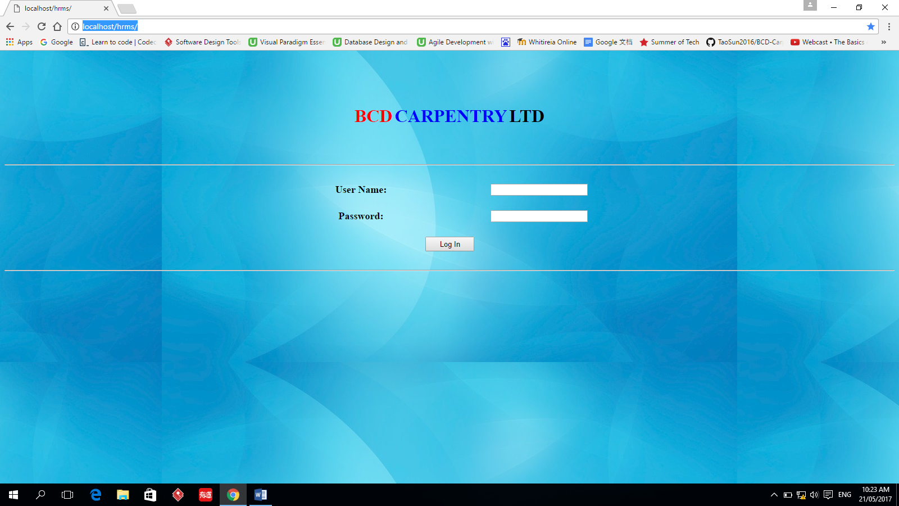

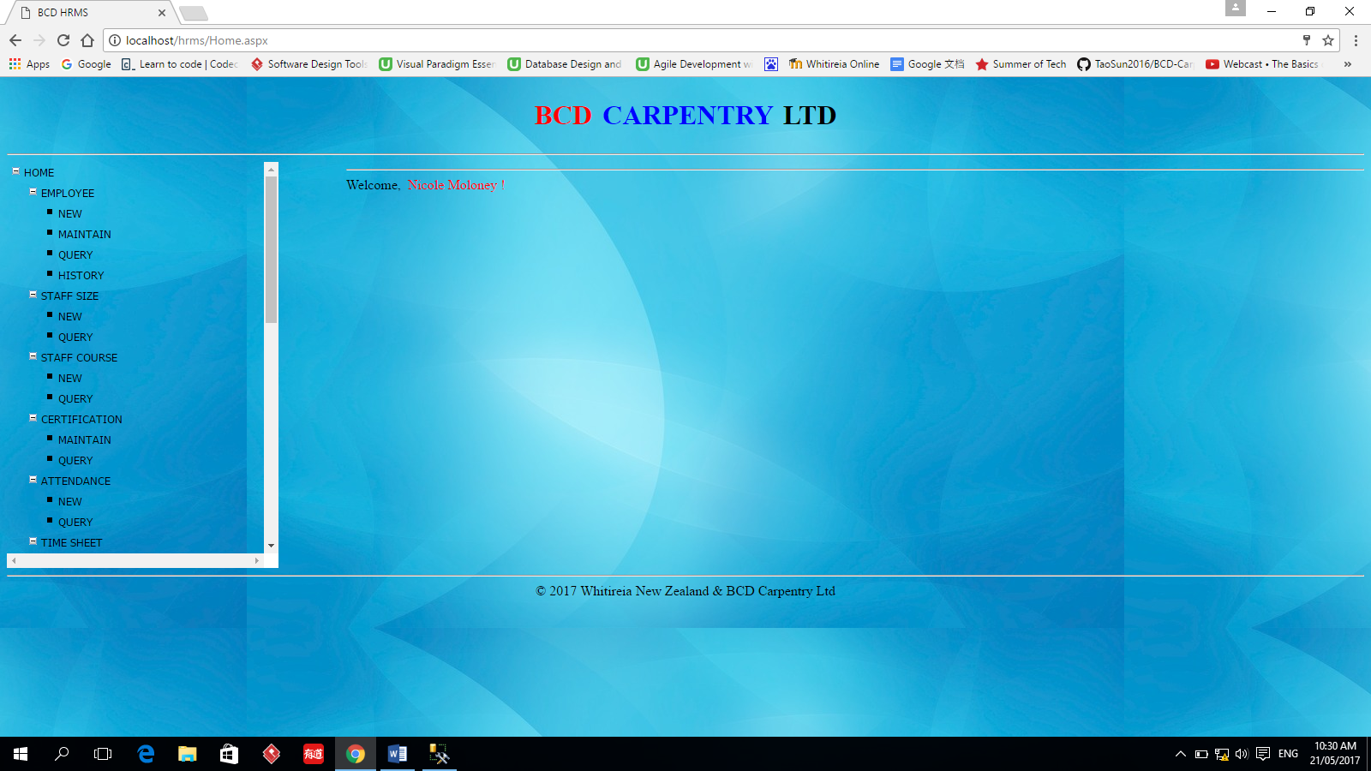

# EMPLOYEE->NEW

This function is used to create new employee information and store the employee information into the database.

Add button is used to add the employee information to the database.

Reset button is used to clear the information on the user’s screen.

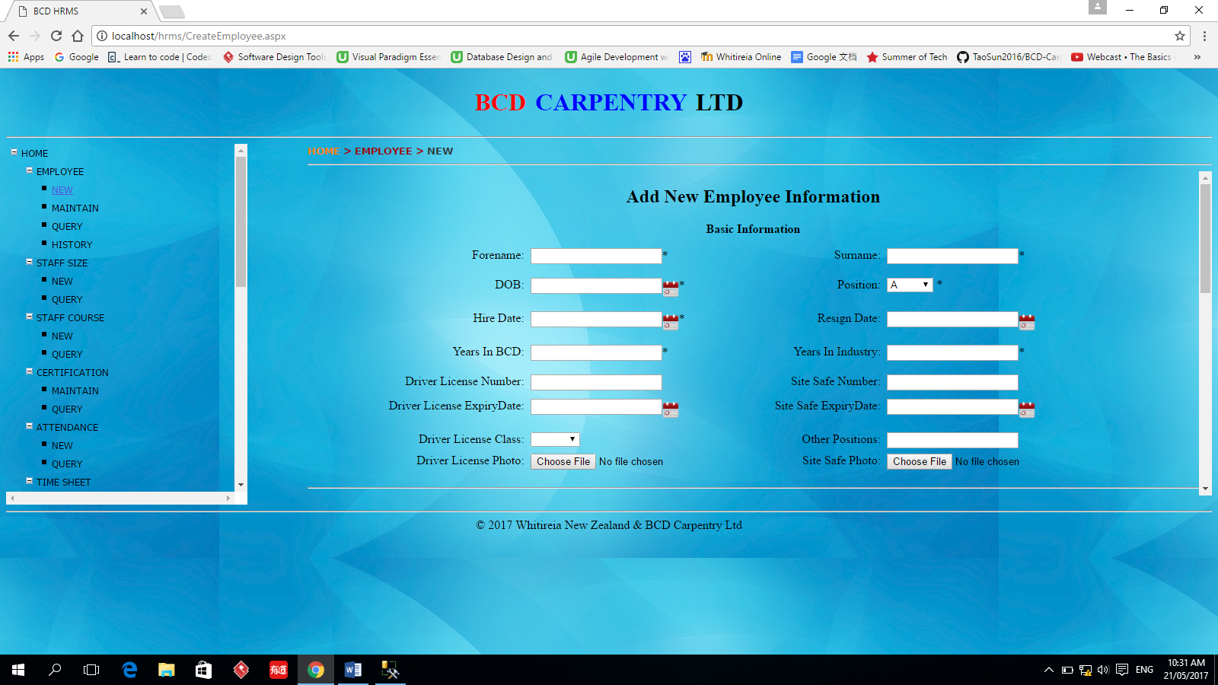

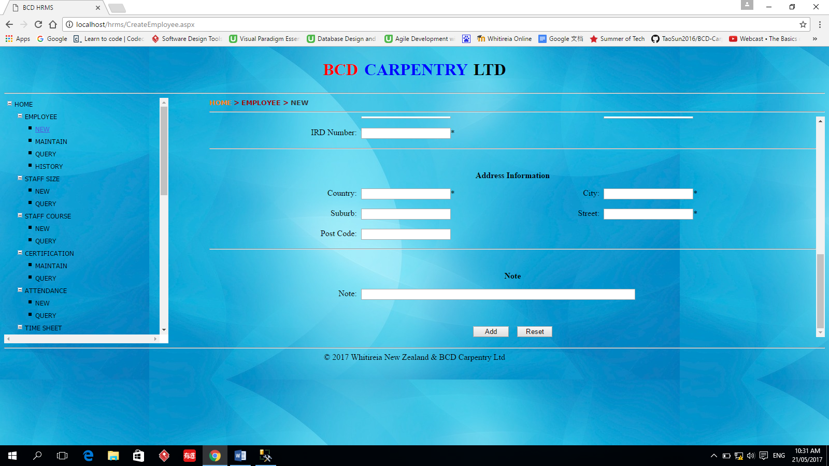

# EMPLOYEE-> MAINTAIN

The function is used to modify the employee’s information whose information has been inputted into the database before.

First input the employee’s name or email information, then click the Query button to retrieve this employee’s information. The result will be showed on the screen. Then the user can modify them or delete them from the database.

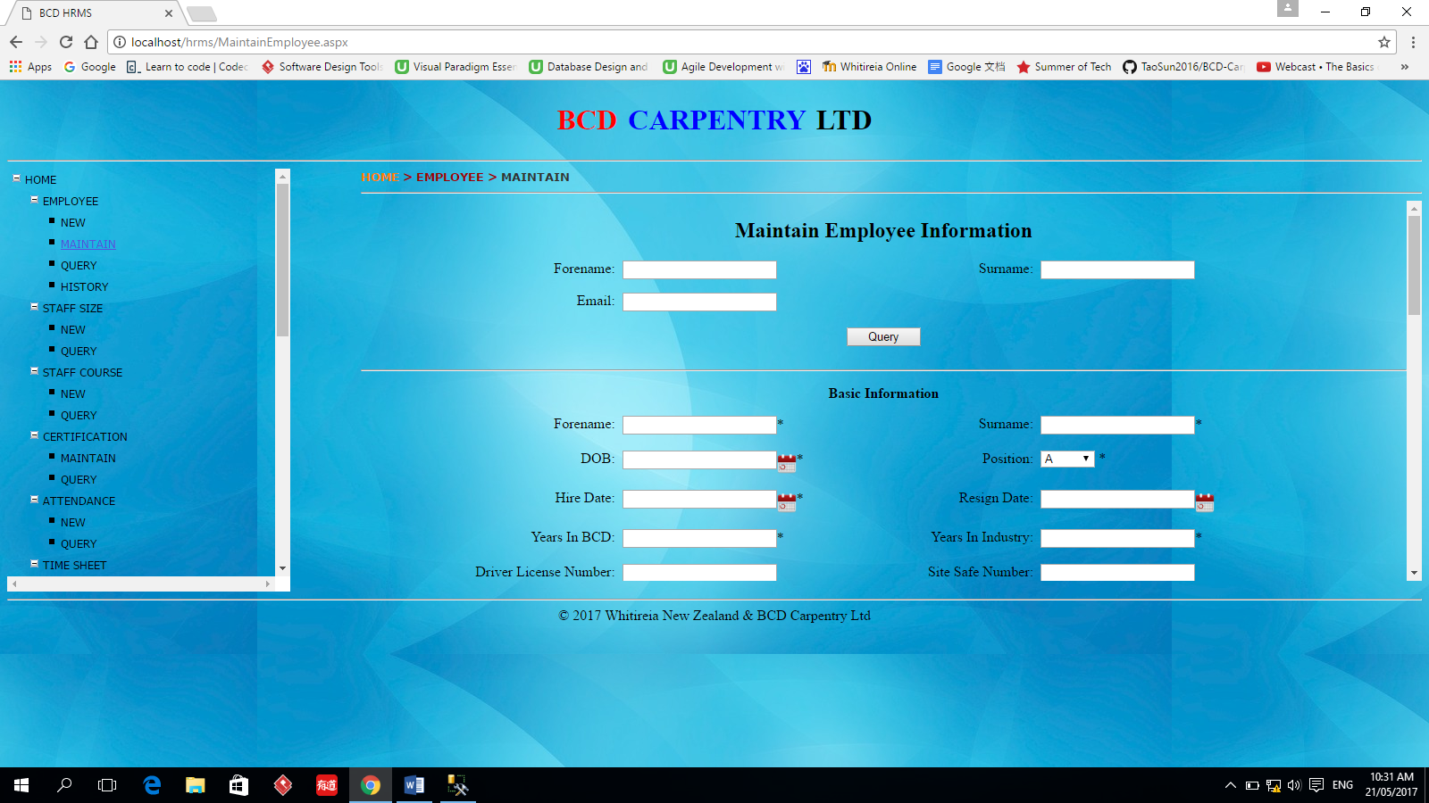

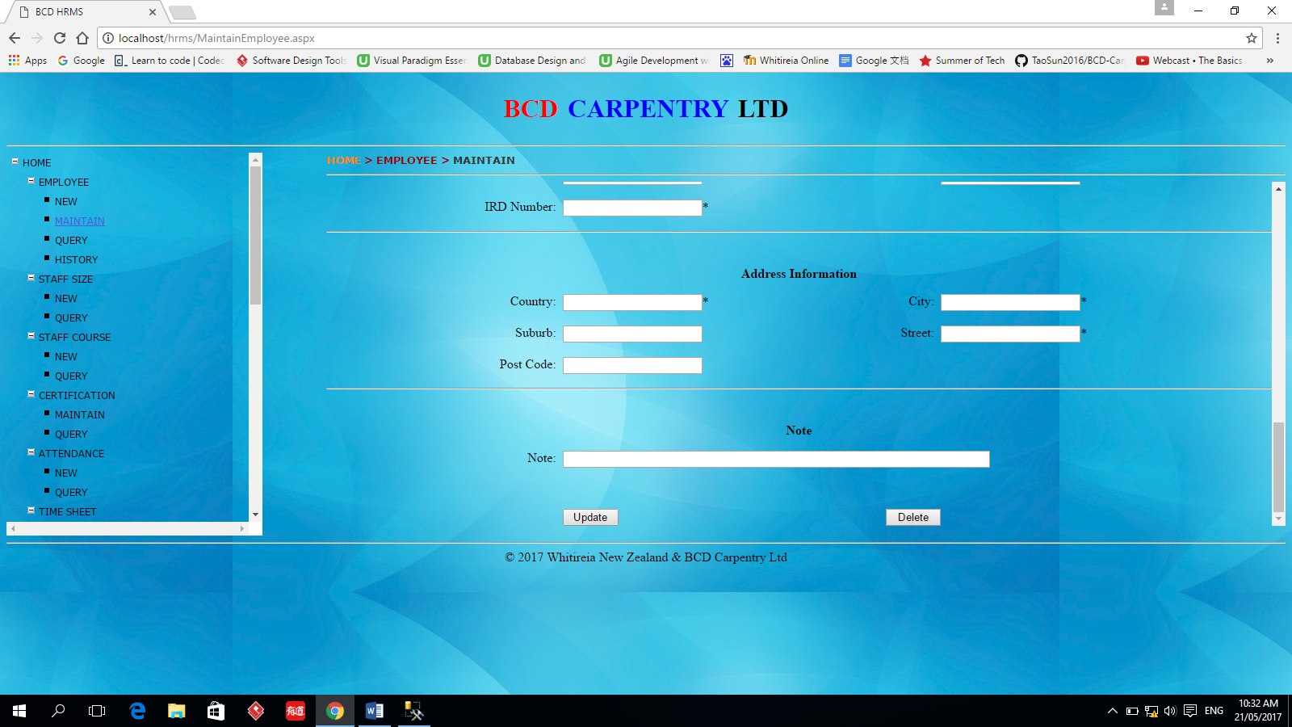

# EMPLOYEE -> QUERY

This function is used to query all of the employees’ information. The user can check the information they want to see then click query button. The information they checked will show up. The query result can be updated, changed and exported to Excel spreadsheet.

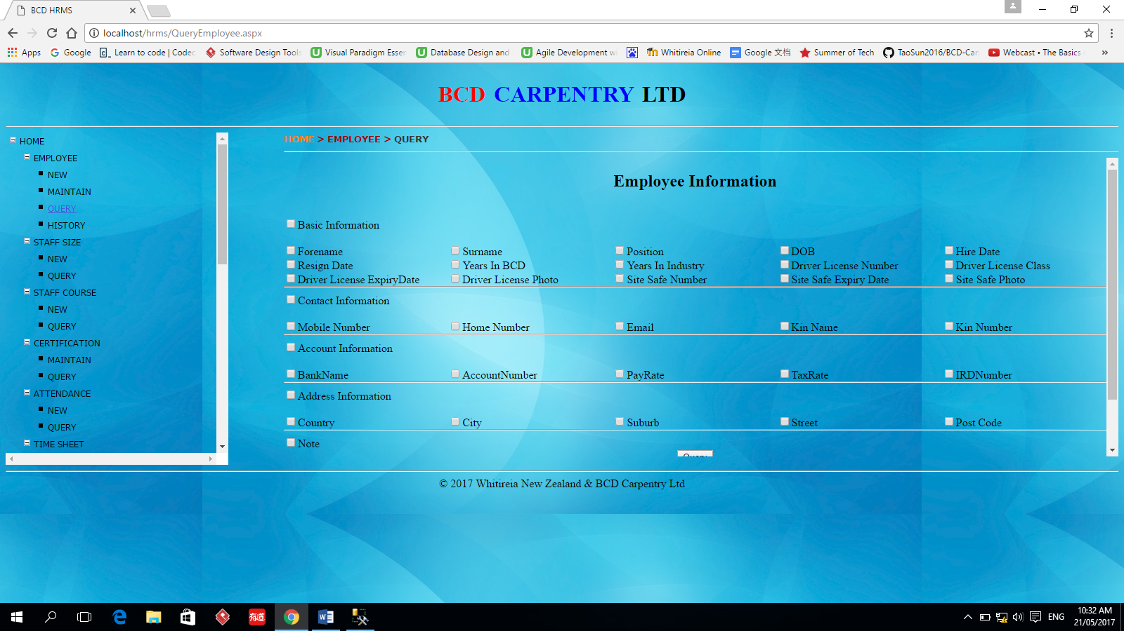

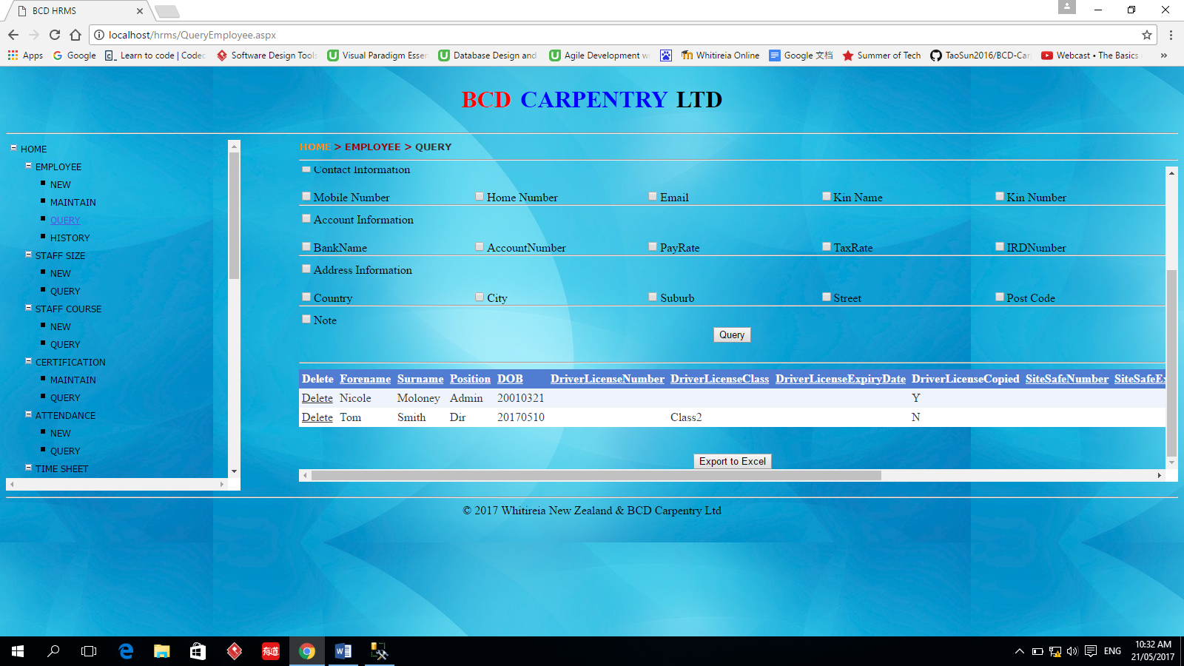

# EMPLOYEE -> HISTORY

When an employee’s information is changed, the old value will be stored by a trigger in the database. This function can see all the historical values of the employee’s information. The user can specify the employee’s name or email they want to query. The query result can be exported to Excel spreadsheet.

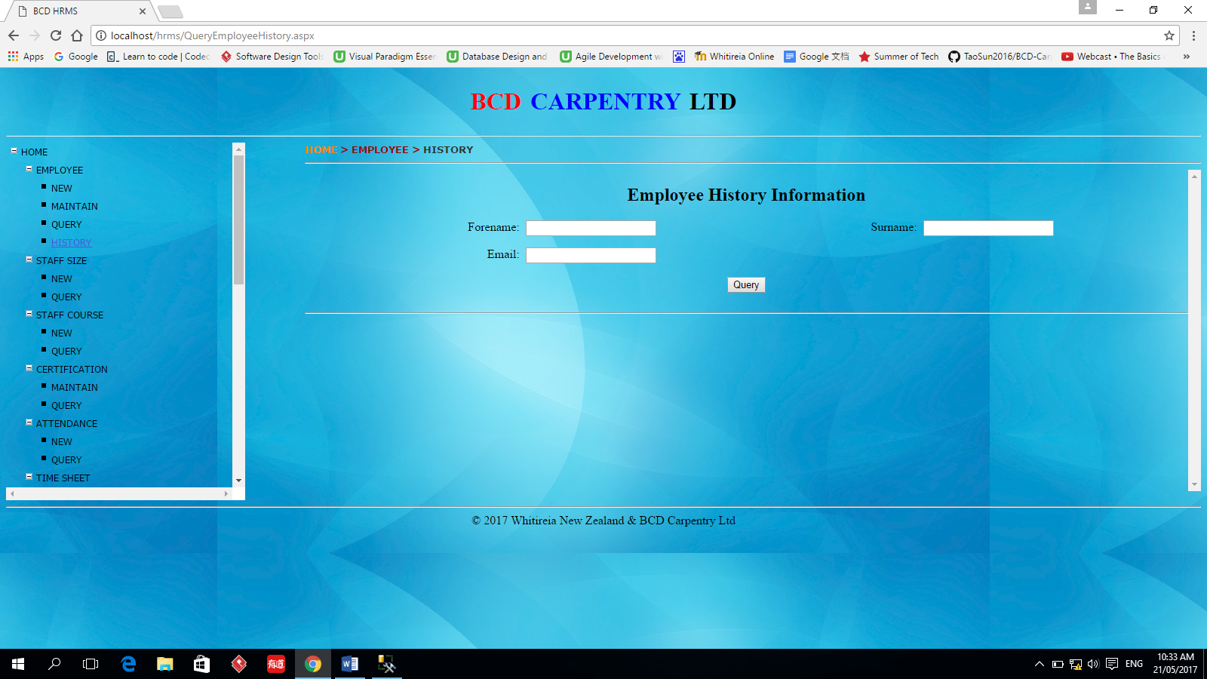

# STAFFSIZE -> NEW

This function is used to input the size information of all kinds of employee’s uniform.

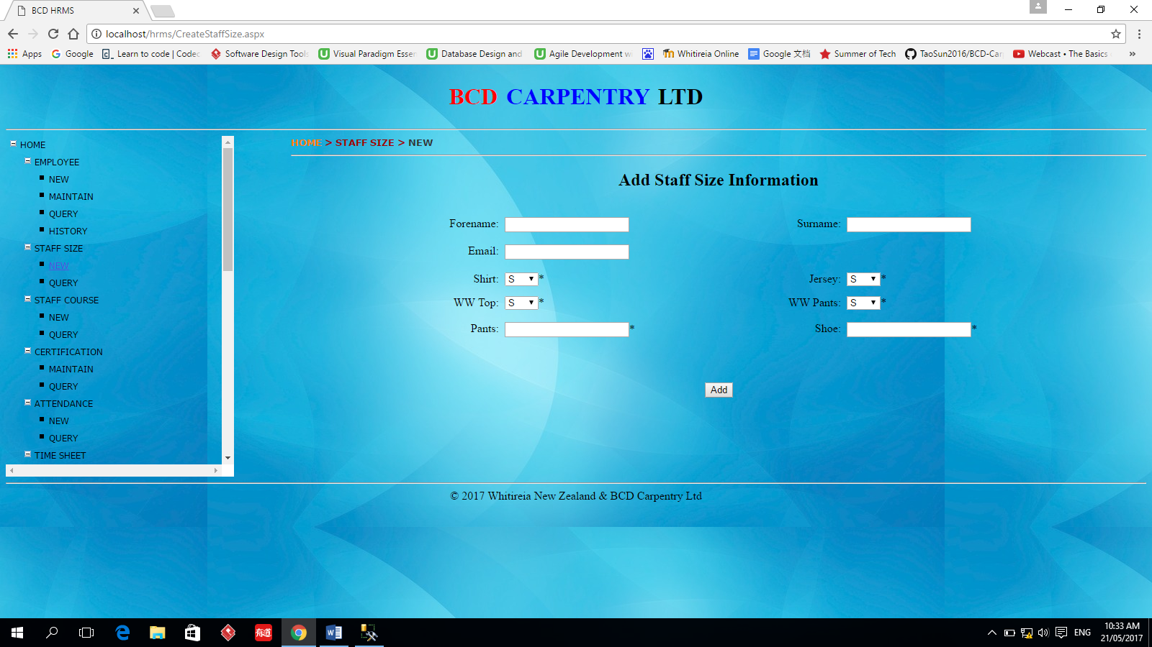

# STAFFSIZE -> QUERY

This function is use to query the size information of employee’s uniform. The user can specify the employee’s name or email address they care about. The query result can be updated, changed and exported to Excel spreadsheet.

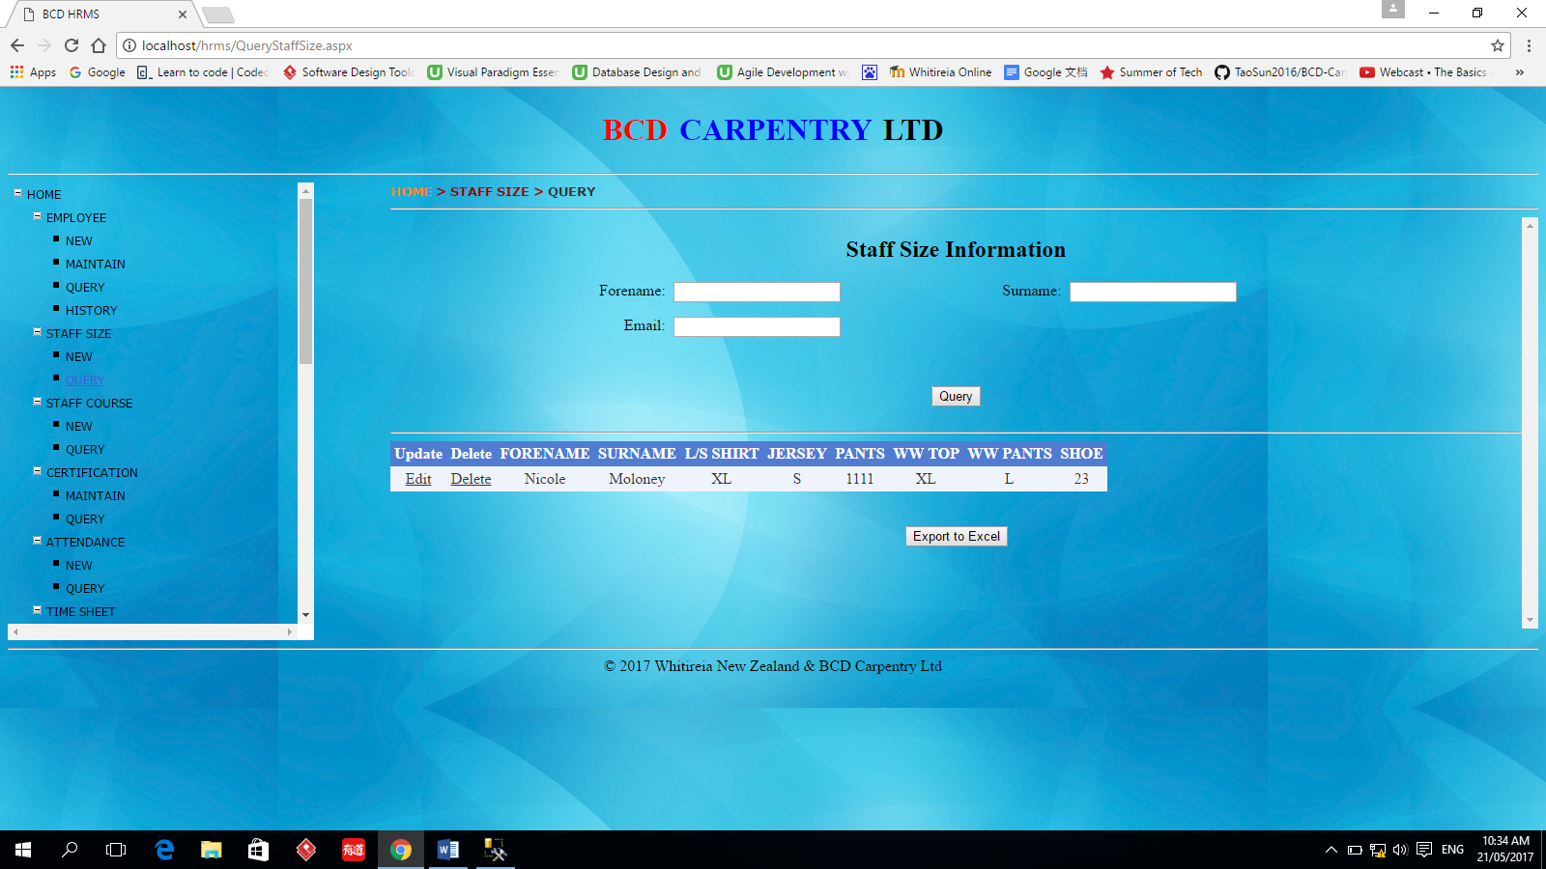

# STAFFCOURSE -> NEW

This function is used to record the employee’s course information

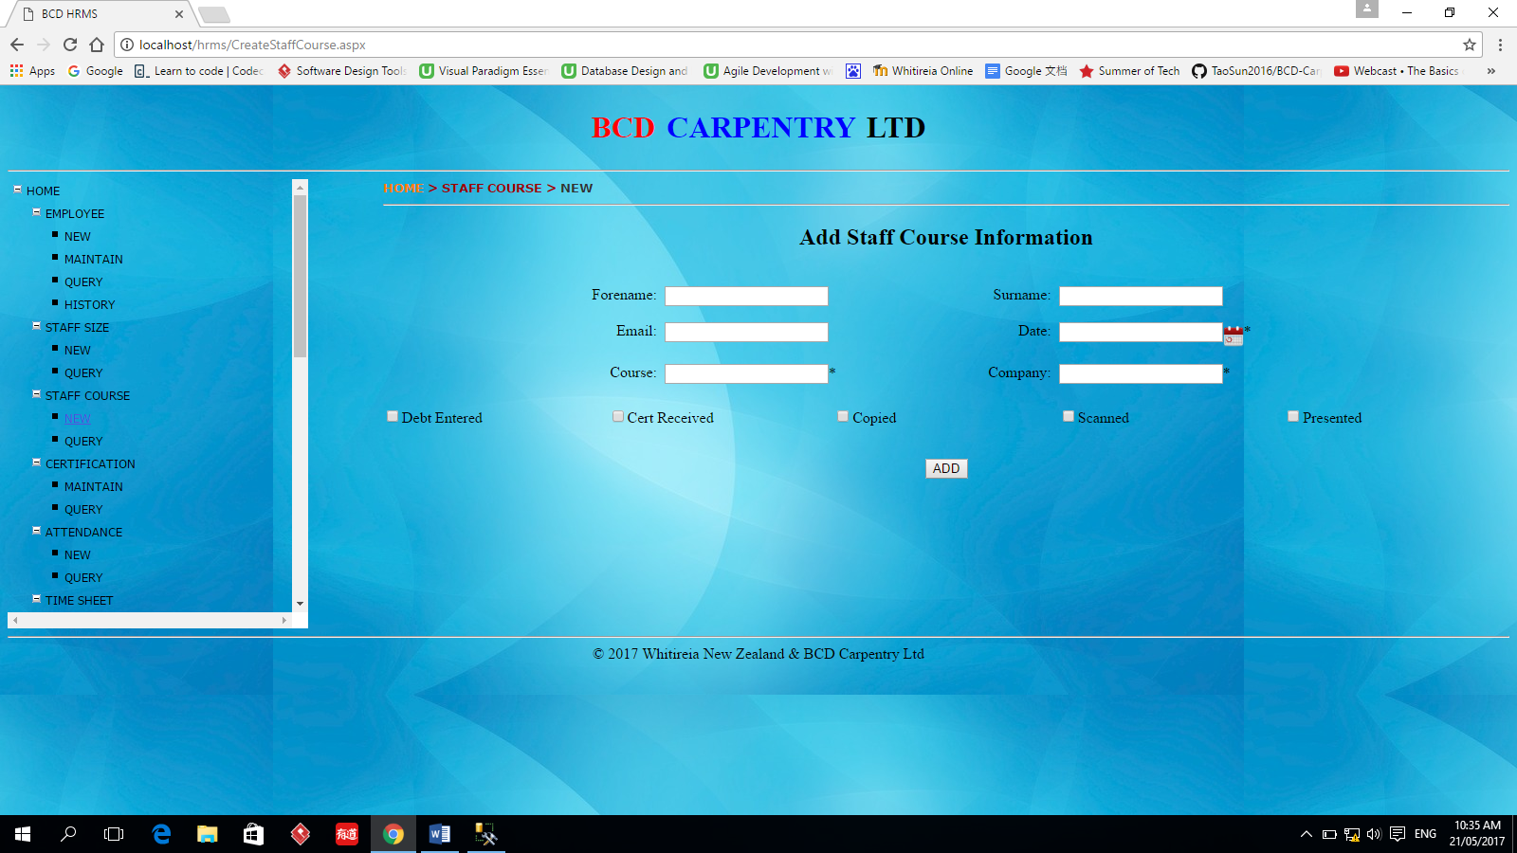

# STAFFCOURSE -> QUERY

This function is used to query the employee’s course information. The query result can be updated, changed and exported to Excel spreadsheet.

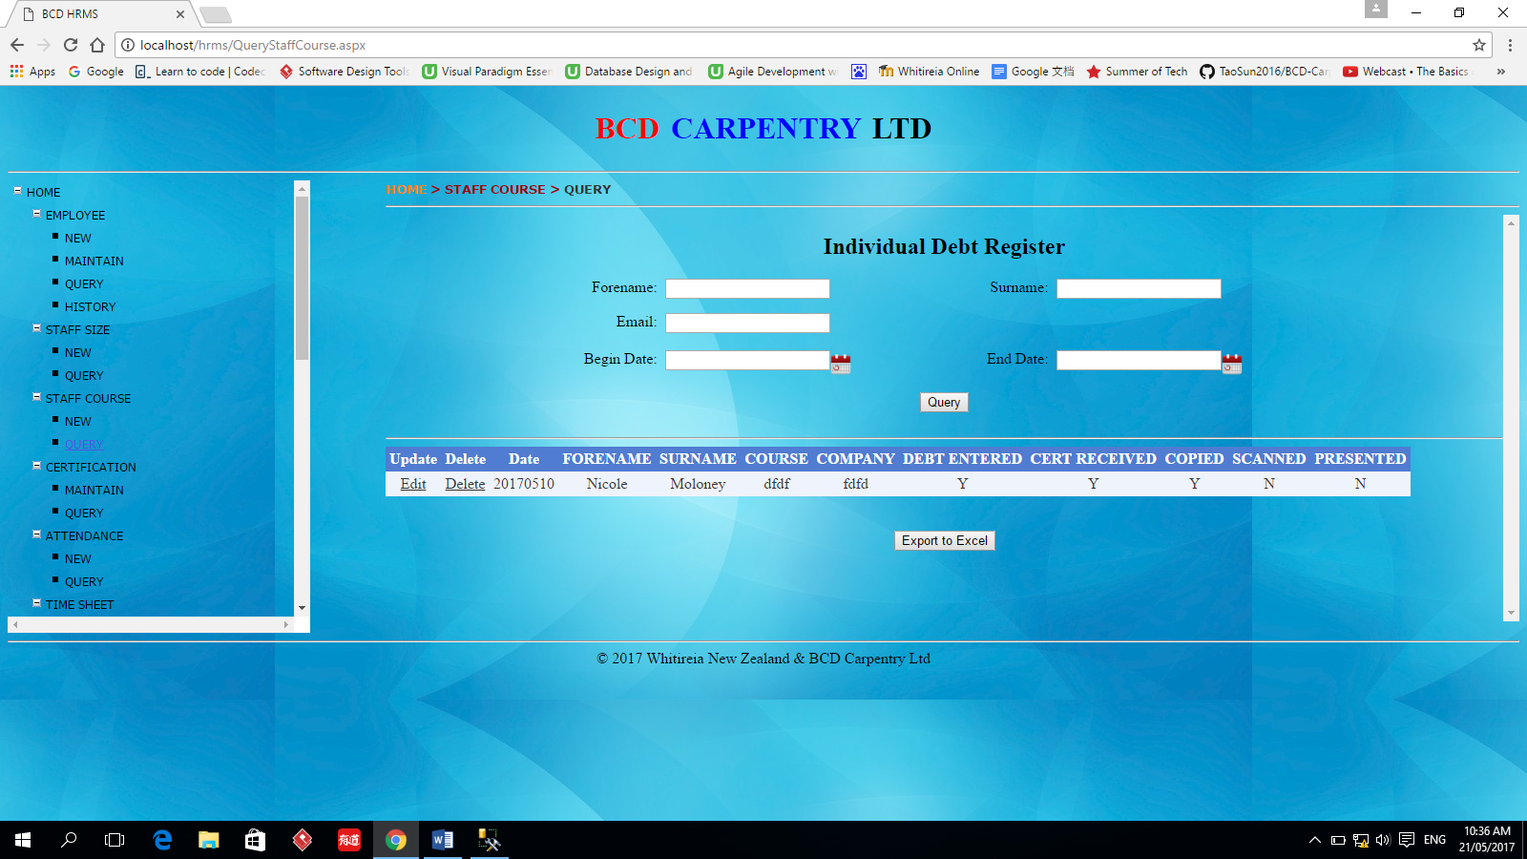

# CERTIFICATION -> MAINTAIN

This function is used to add or update employee’s certification information.

The employee’s name or email must be specified first then click Query button. If the employee’s certification information has been stored in the database, their value will be showed and can be updated. When the query action executes successfully, the Add/Update button and Delete button also show up. After the information is input or modified, the user can click Add/Update button to add or update them. They also can click Delete button to delete this employee’s certification information form the database.

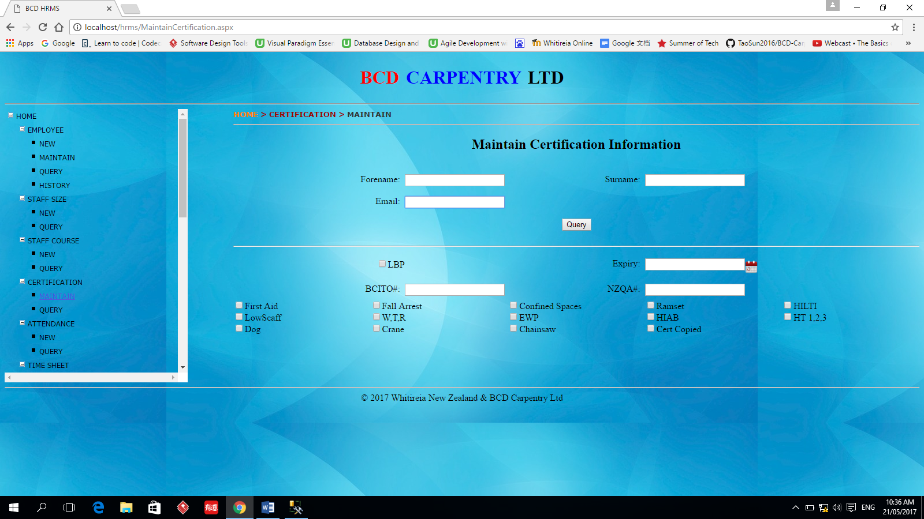

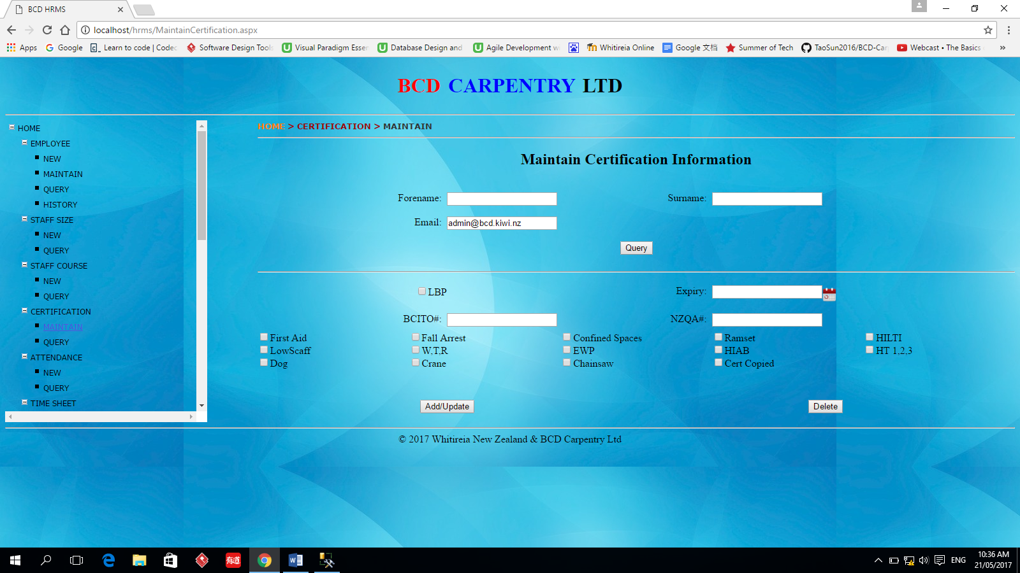

# CERTIFICATION -> QUERY

This function is used to query one or all employee’s certification information. The query result can be updated, changed and exported to Excel spreadsheet.

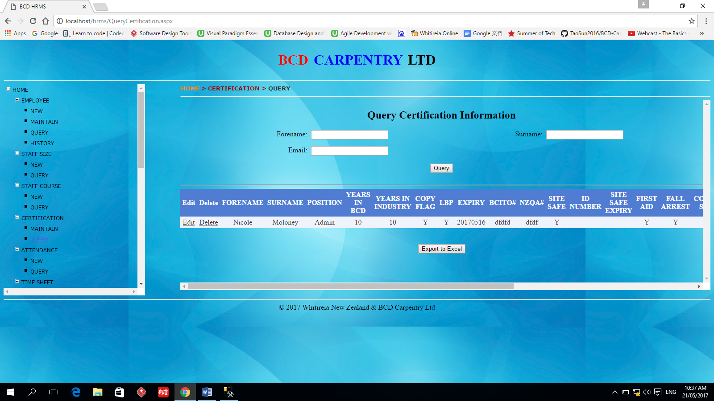

# ATTENDANCE -> NEW

This function is used to record the employee’s attendance information.

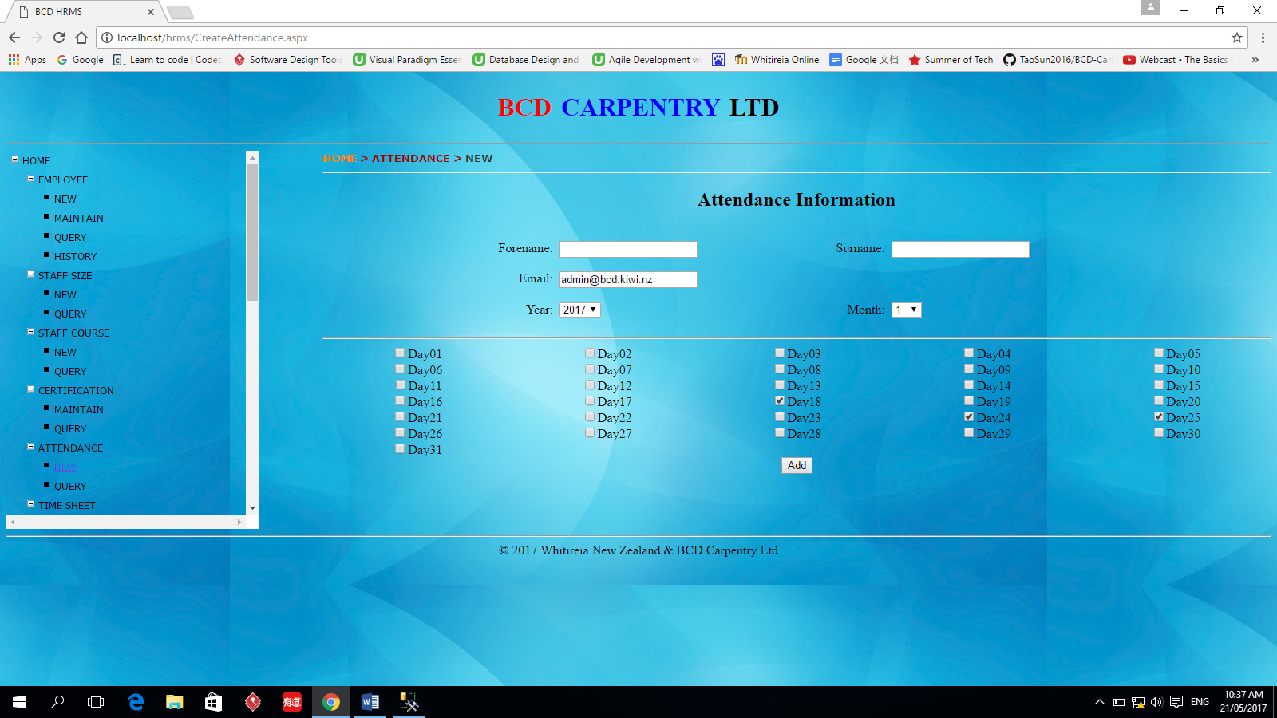

# ATTENDANCE -> QUERY

This function is used to query the employee’s attendance information. The user can specify the name, email, year and month as query conditions. The query result can be updated, changed and exported to Excel spreadsheet.

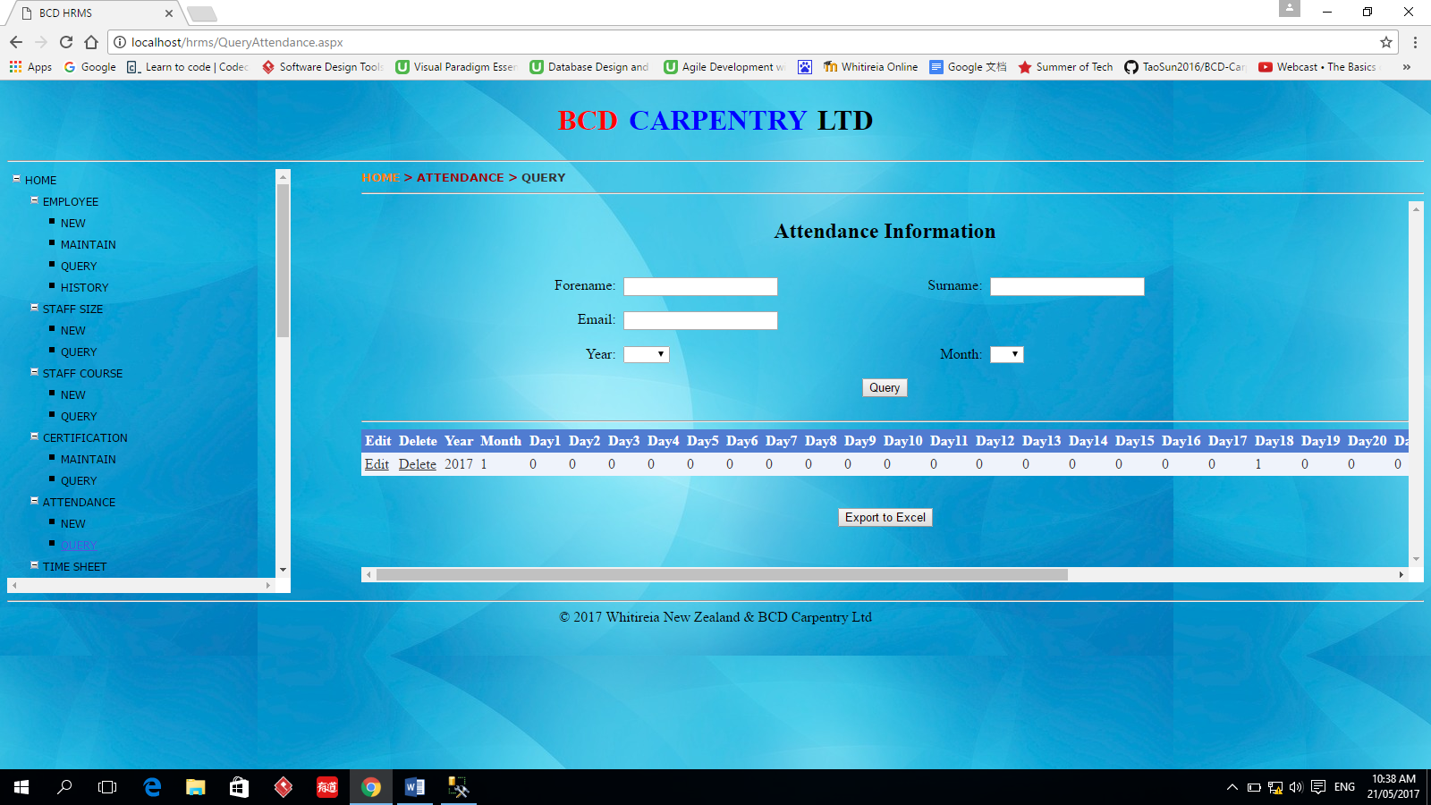

# TIMESHEET -> NEW

This function is used to create new time sheet record.

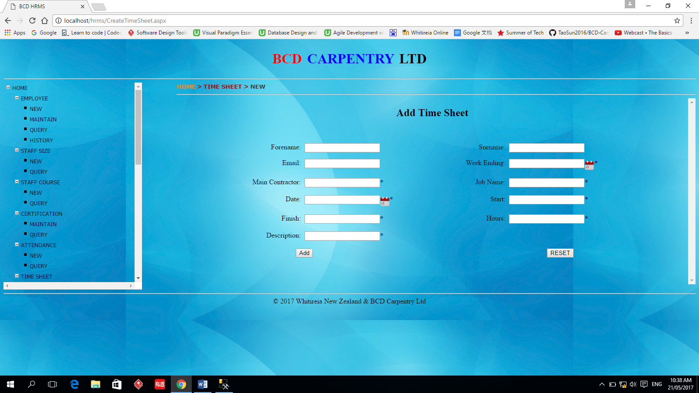

# TIMESHEET -> QUERY

This function is used to query the time sheet information. The query result can be updated, changed and exported to Excel spreadsheet.

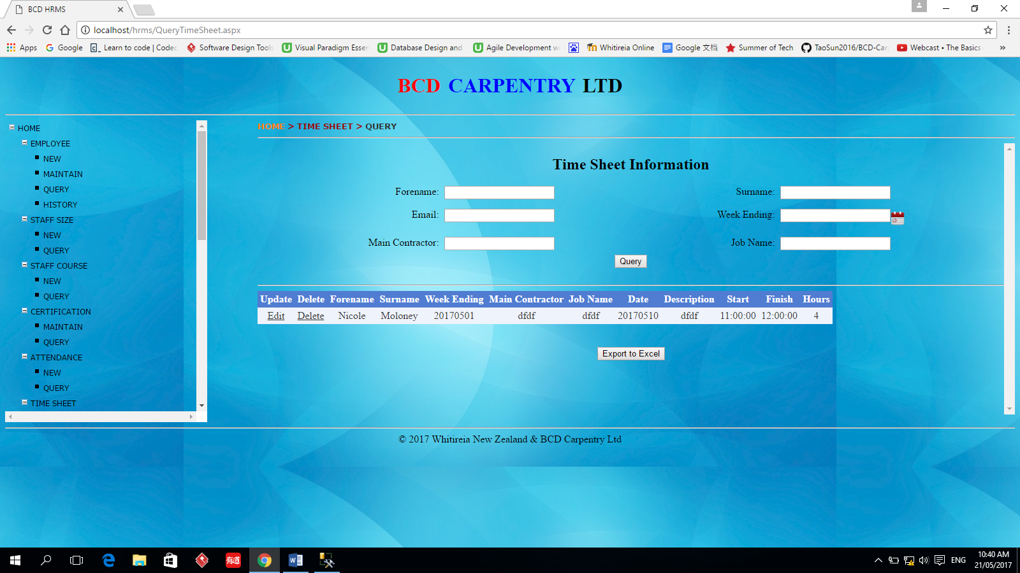

# WAGE -> NEW

This function is used for the user to input the employee’s wage information.

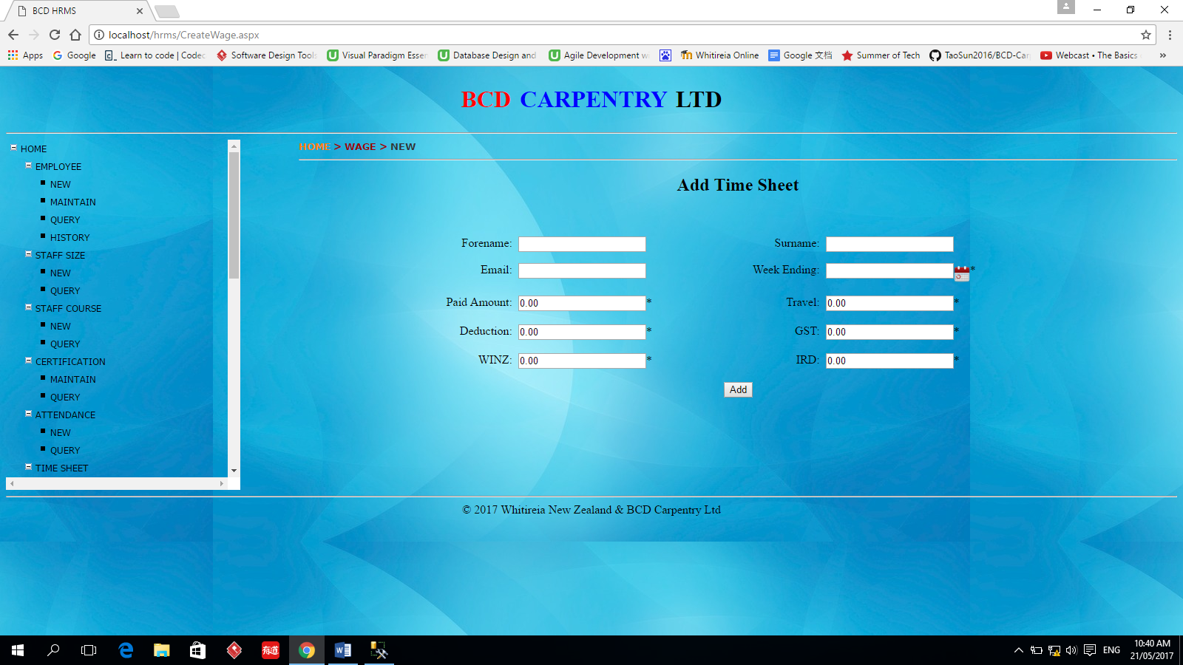

# WAGE -> QUERY

This function is used to query the employee’s wage information. The user can specify the employee’s name or email information. The week ending data can also be input as query condition. The query result can be updated, changed and exported to Excel spreadsheet.

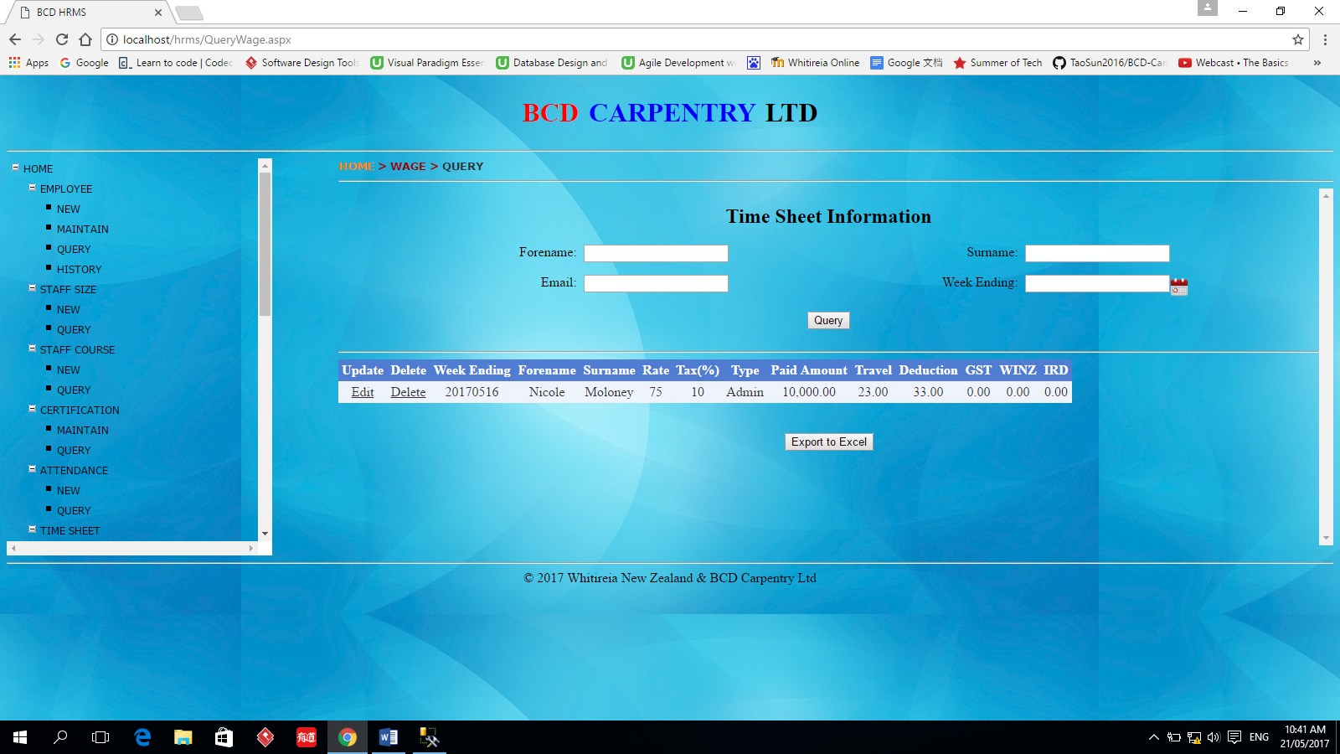

# TAX -> NEW

This function is used to add employee’s tax information.

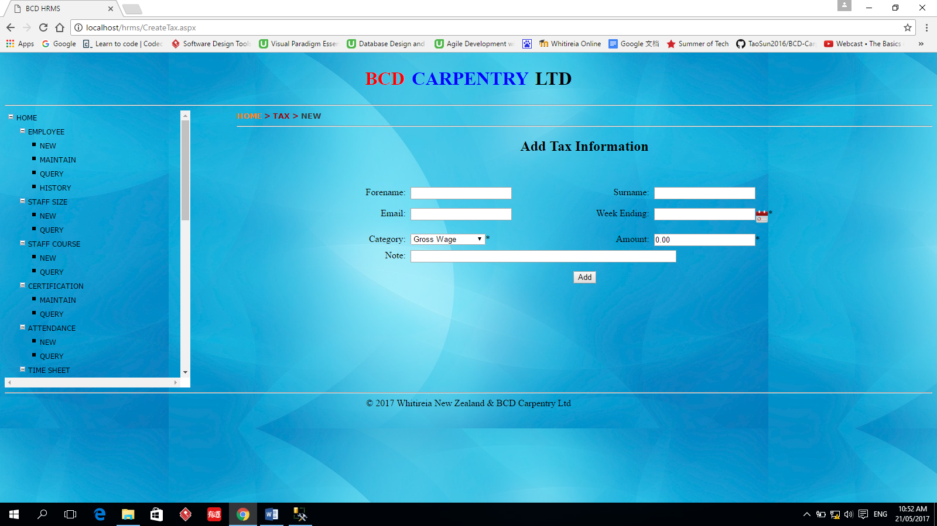

# TAX -> MAINTAIN

This function is used to update and delete employee’s tax information. The query result can be updated, changed and exported to Excel spreadsheet.

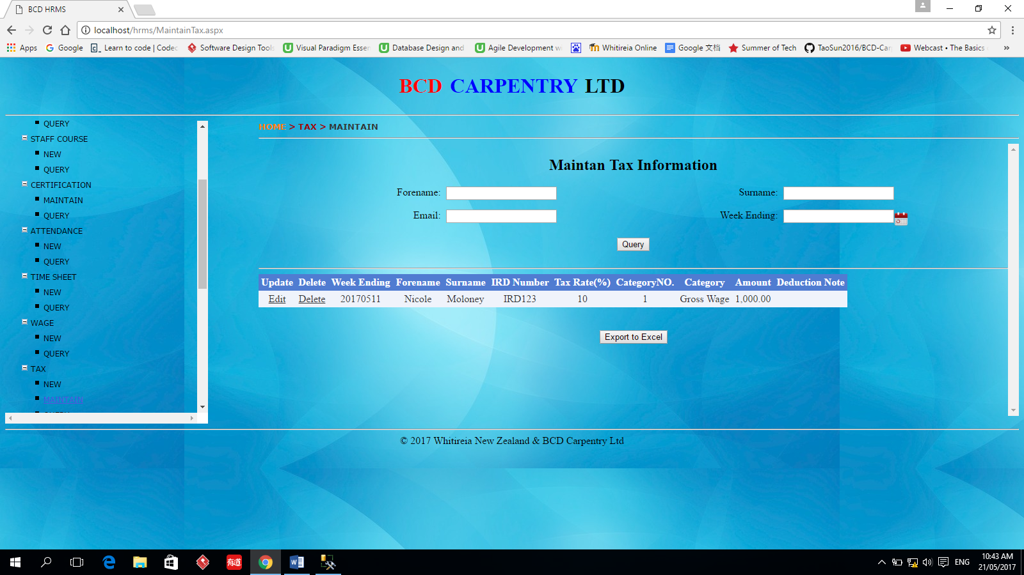

# TAX -> QUERY

This function is a report. The user can query the tax information in a specified phase.

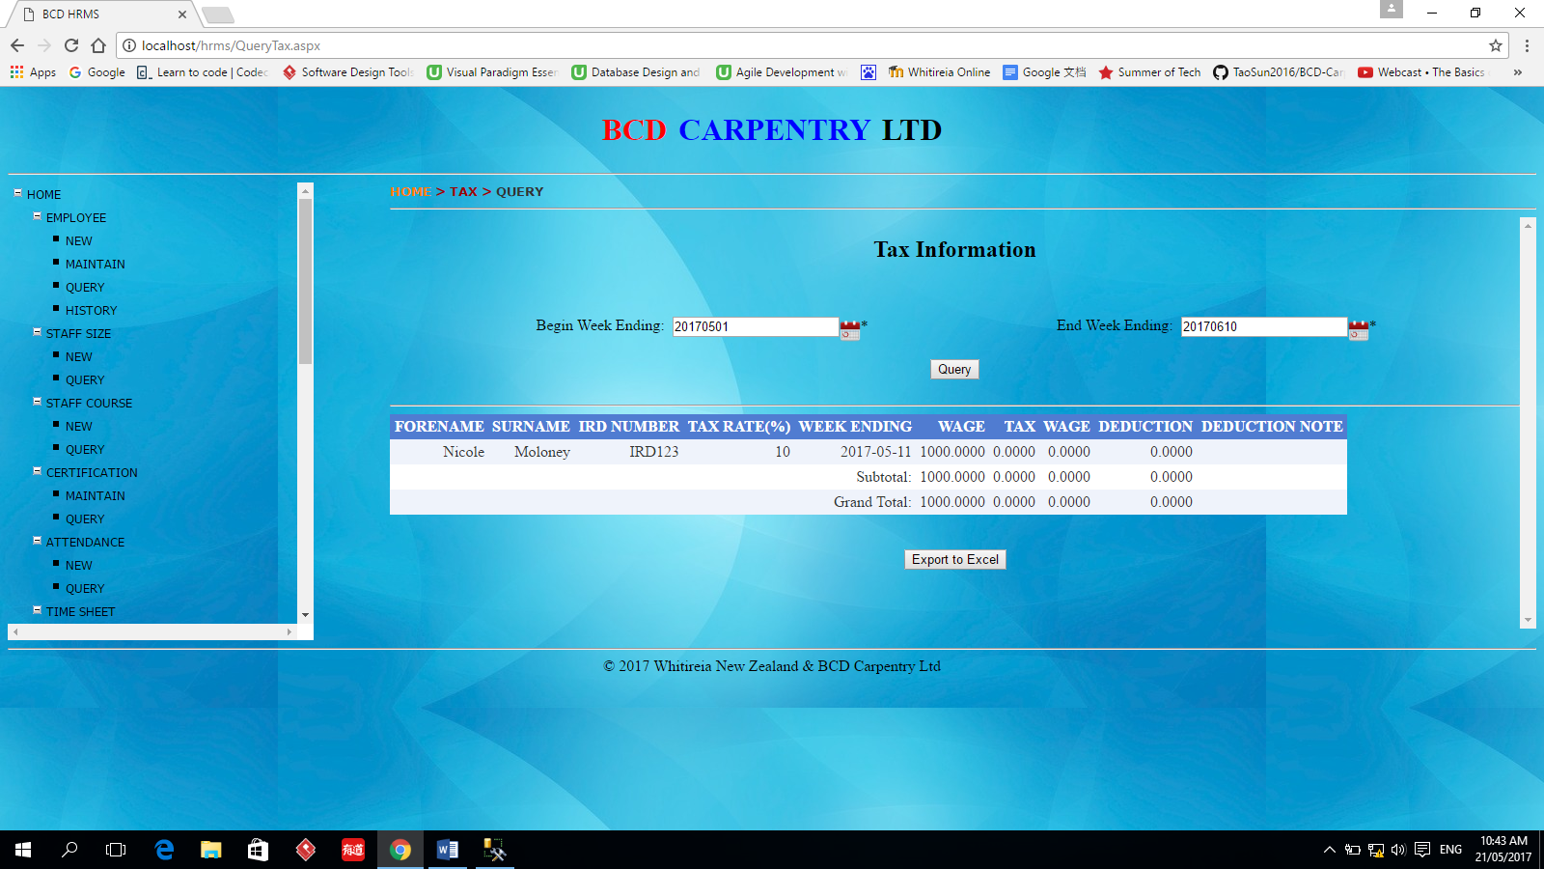

# INDIVIDUALDEBT -> NEW

This function is used to record the employee’s debt information.

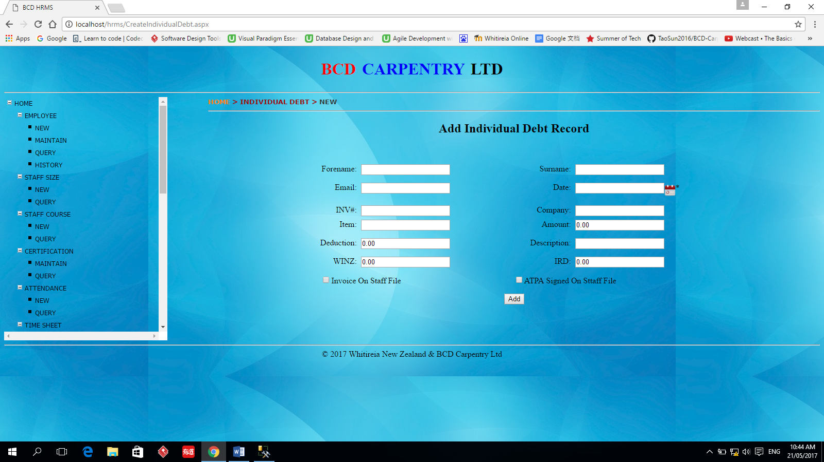

# INDIVIDUALDEBT -> QUERY

This function is used to query employee’s debt information. The user can specify some query conditions showed below. The query result can be updated, changed and exported to Excel spreadsheet.

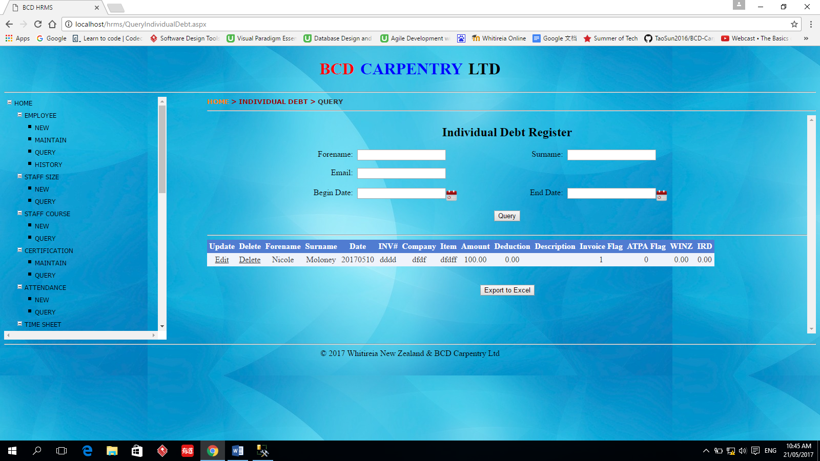

# COMPETENCY

In this function, the user need to input one employee’s name or email to query the relative information first. Then the user can add, update, and delete the information. It even can be exported into PDF format.

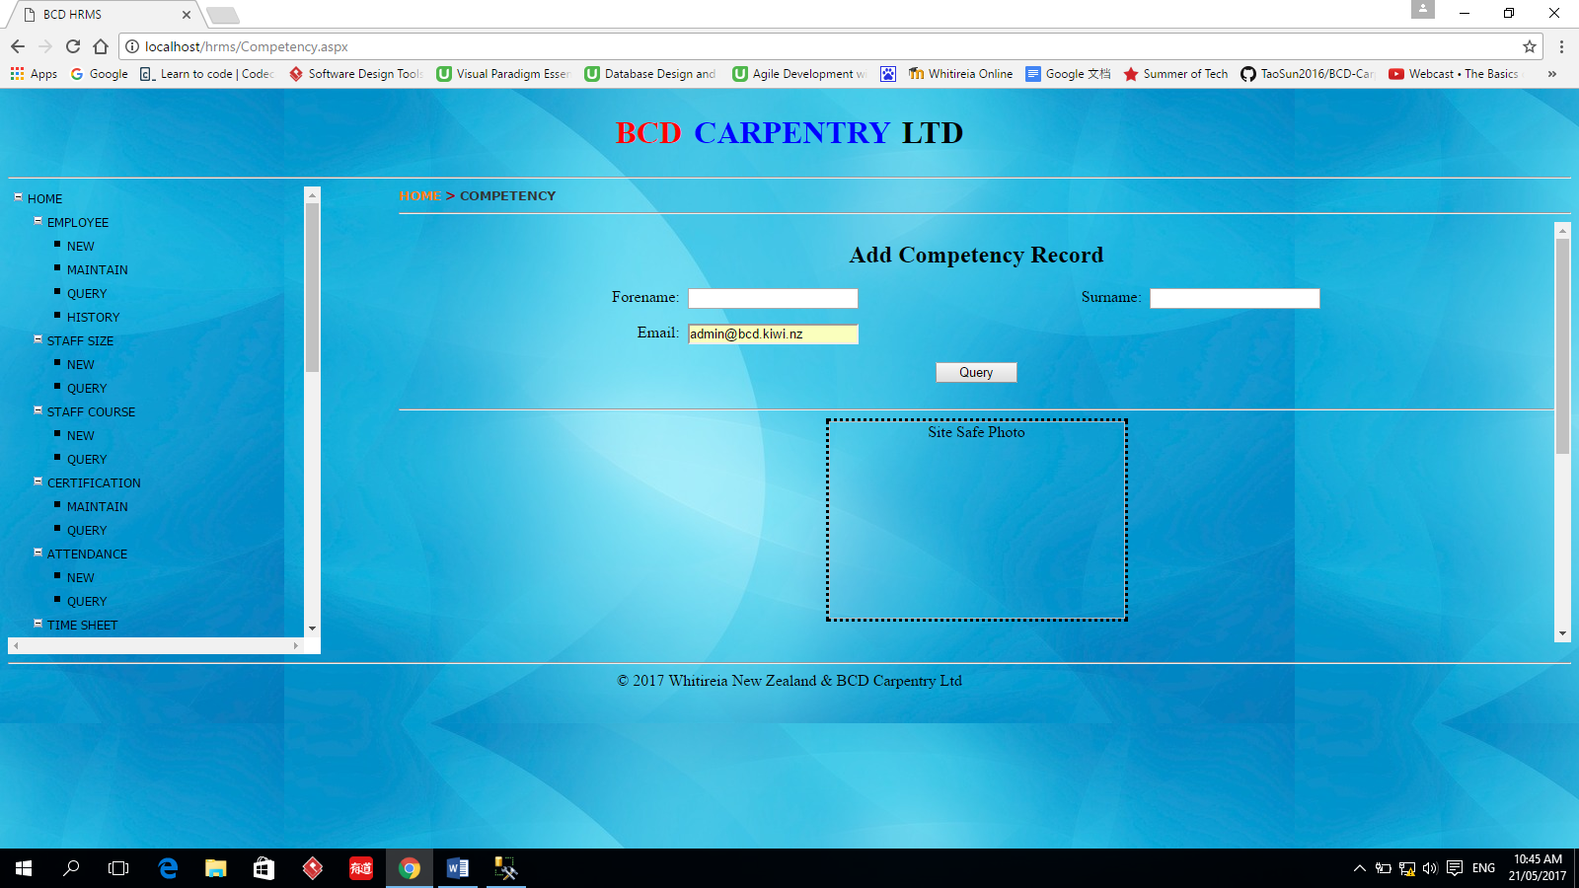

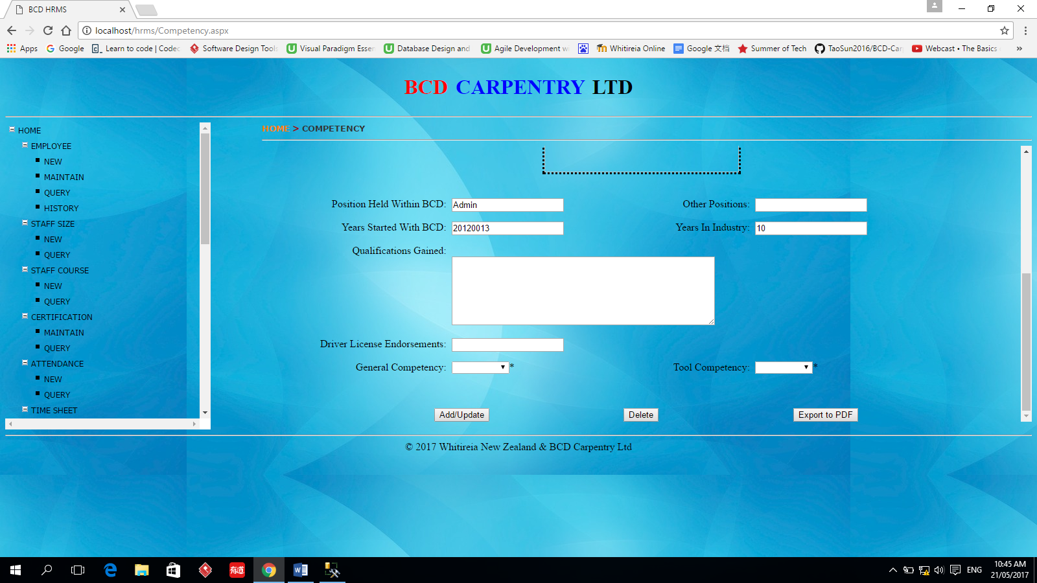

# TOOL -> TOOLUSE -> New

This function is used to register the information about how the tools are used.

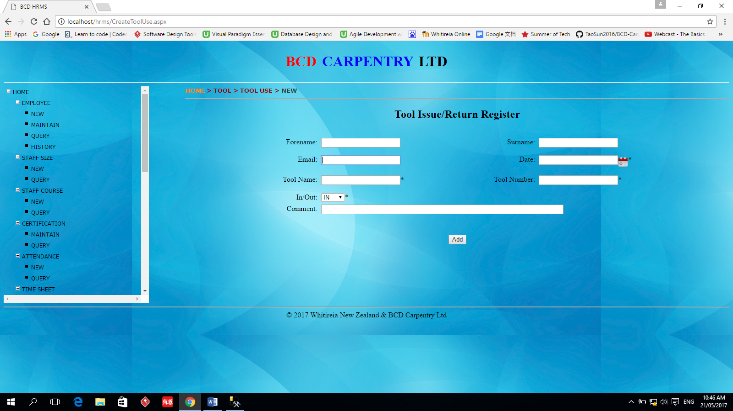

# TOOL -> TOOLUSE-> QUERY

This function is used to query the information about the tools’ use. The query result can be updated, changed and exported to Excel spreadsheet.

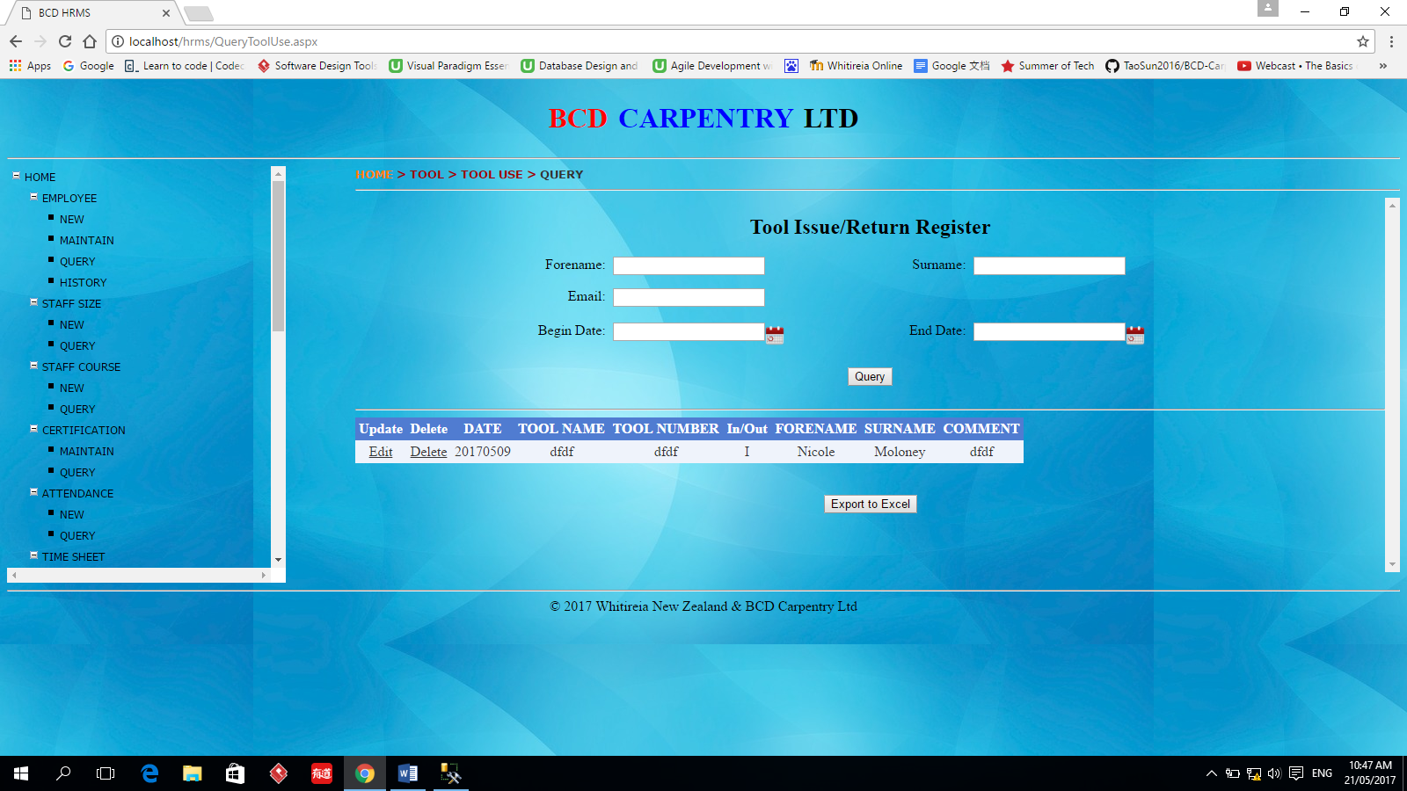

# TOOL -> TOOLLIST -> NEW

This function is used to add new tool list information.

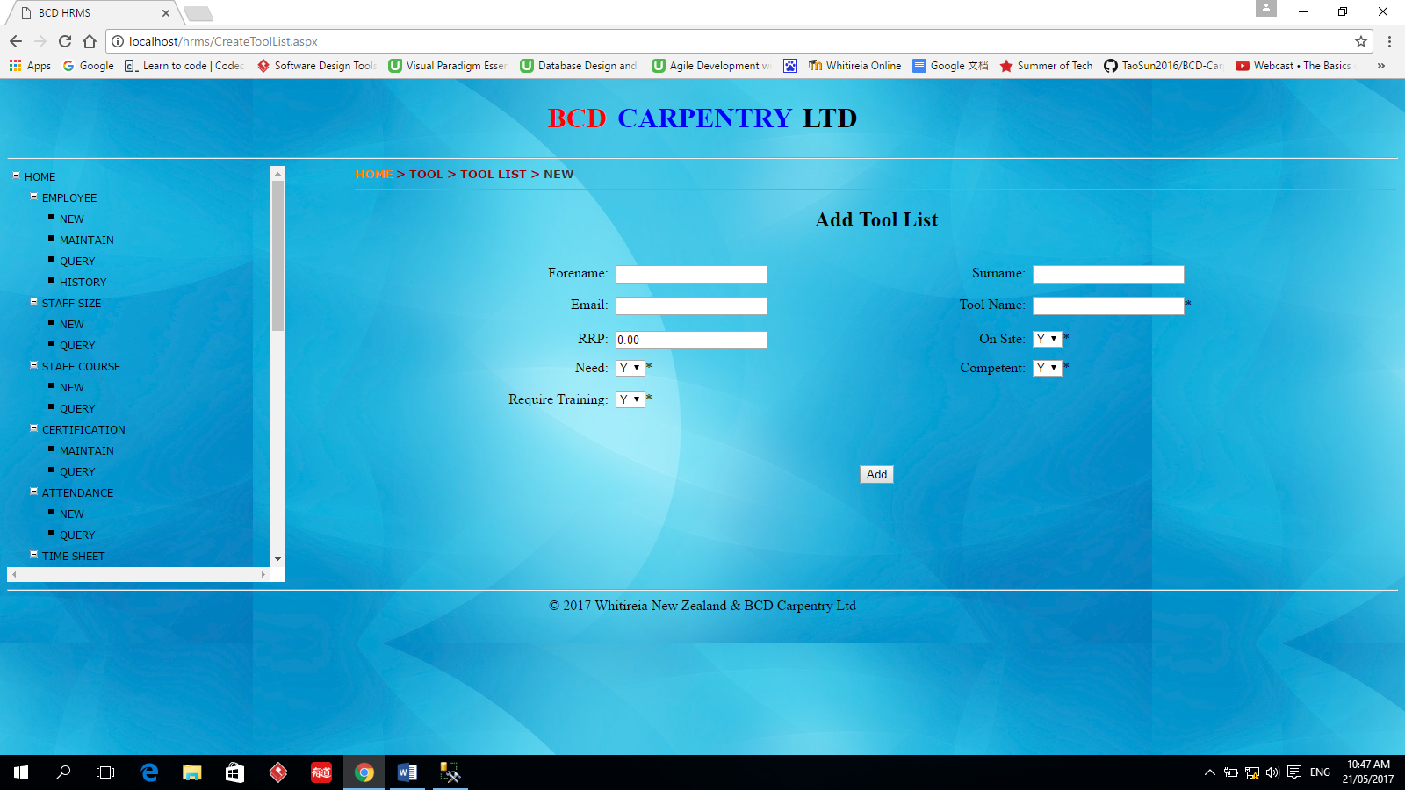

# TOOL -> TOOLLIST -> QUERY

This function is used to query employee’s toll list information. The user can specify the concrete employee to query. The query result can be updated, changed and exported to Excel spreadsheet.

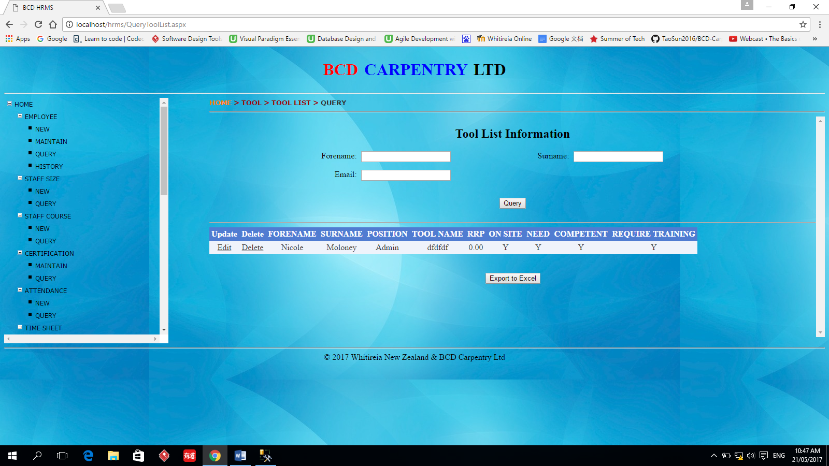

# TOOL -> TOOLTRAINING -> ADD

This function is used to register the employee’s training information.

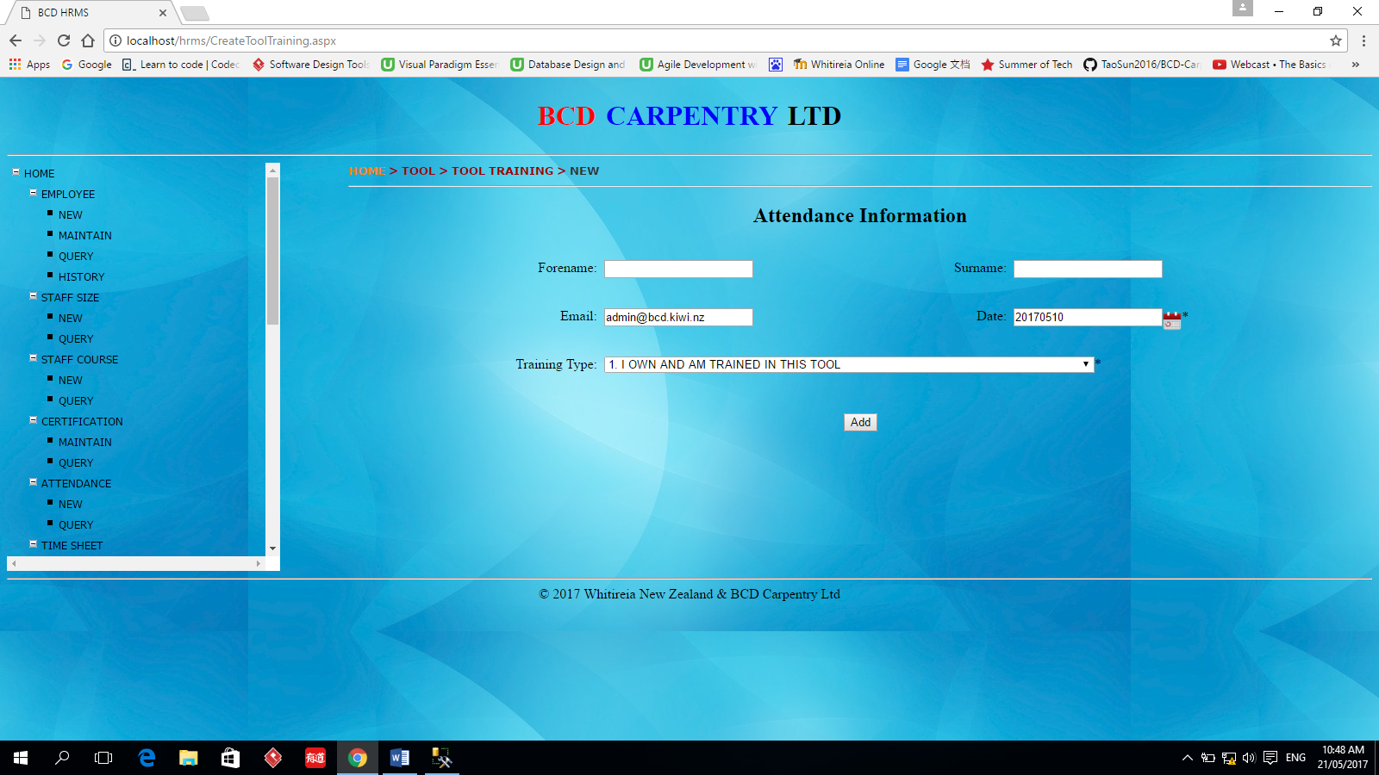

# TOOL -> TOOLTRAINING -> QUERY

This function is used to query the employee’s training information. The query result can be updated, changed and exported to Excel spreadsheet.

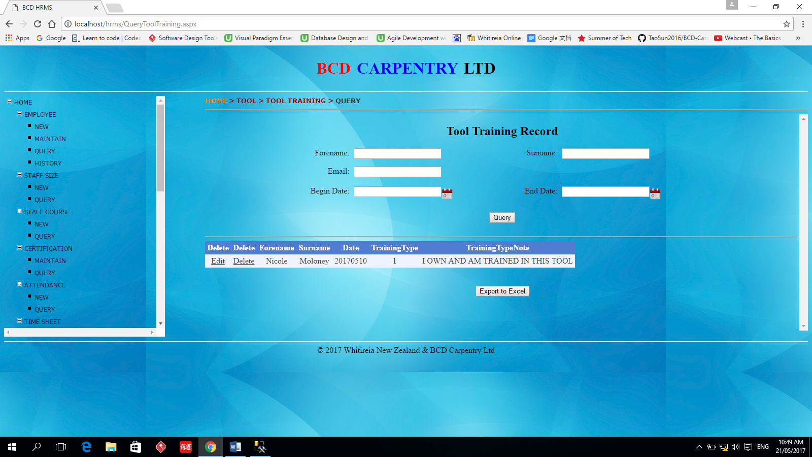

# VEHICLE -> NEW

This function is used to register the information of vehicles belong to BCD Carpentry Ltd.

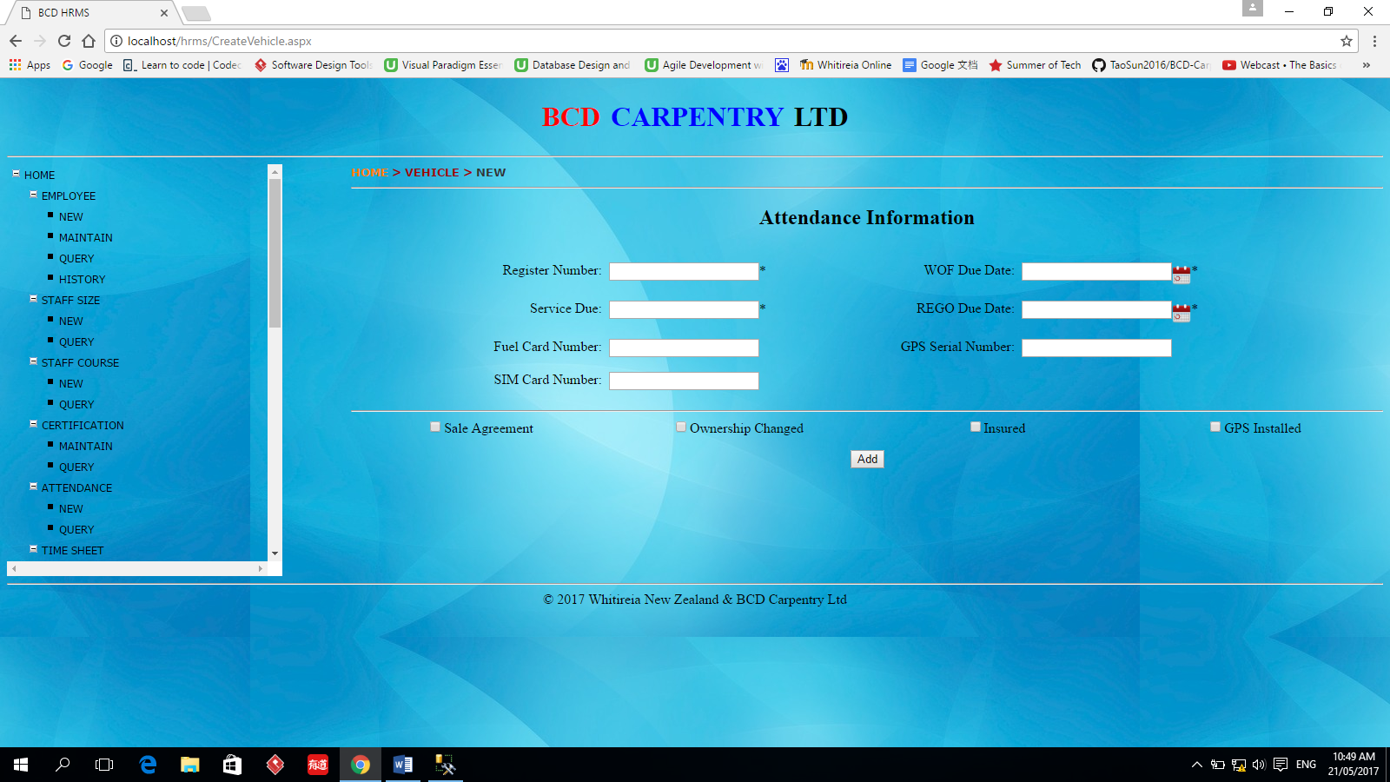

# VEHICLE -> QUERY

This function is used to query the vehicle information registered before. The information can also be updated and deleted in this function. The query result can be updated, changed and exported to Excel spreadsheet.

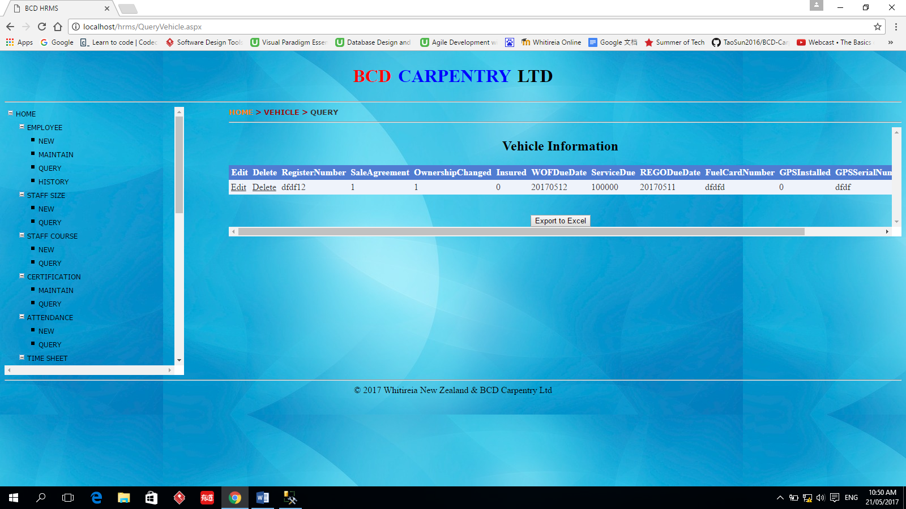

# CHANGEPASSWORD

The user use this function to change one employee’s password. Now this function can change any employee’s password.

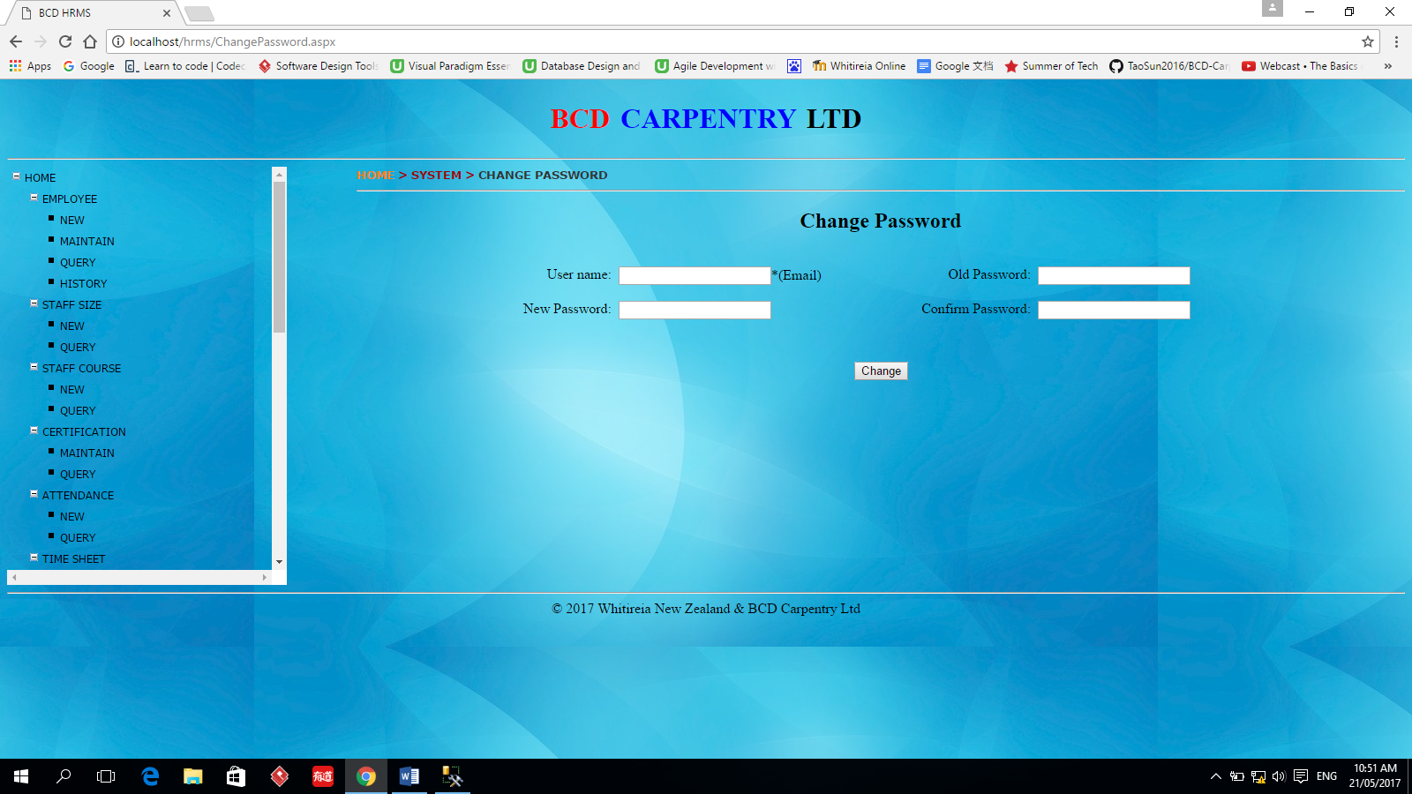

# Database Restore

# Login SQL Server Management Studio

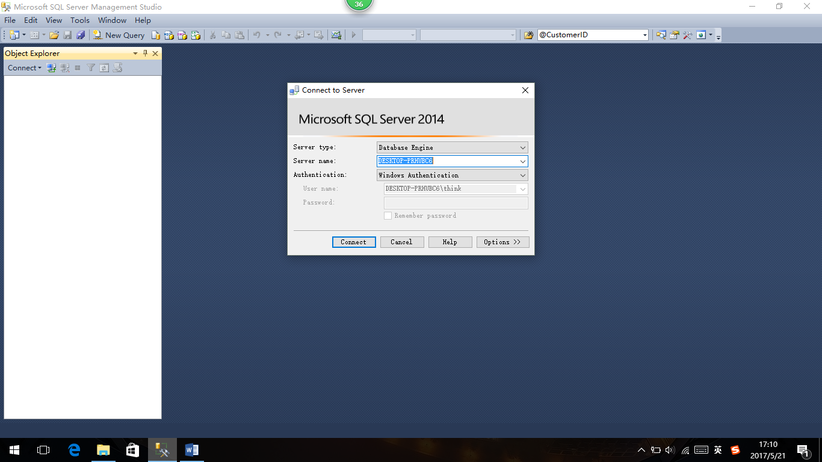

# Right click database, choose Restore Database…

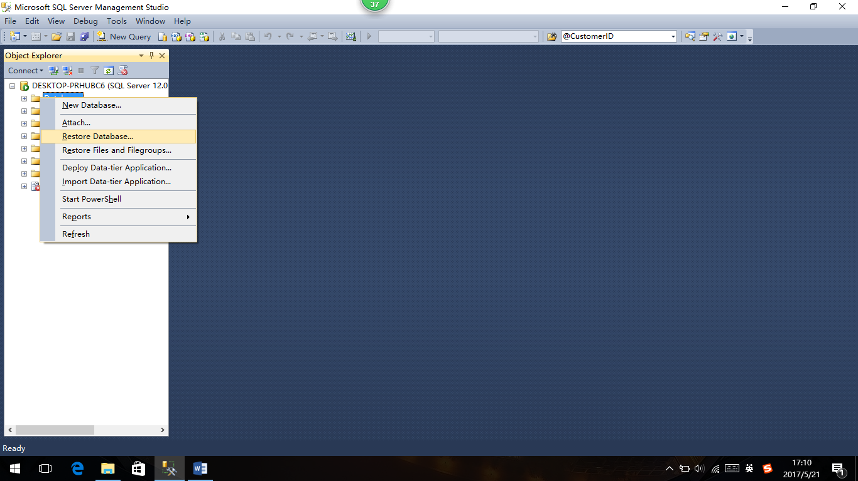

# Restore Database window will appear, choose device and click the … button

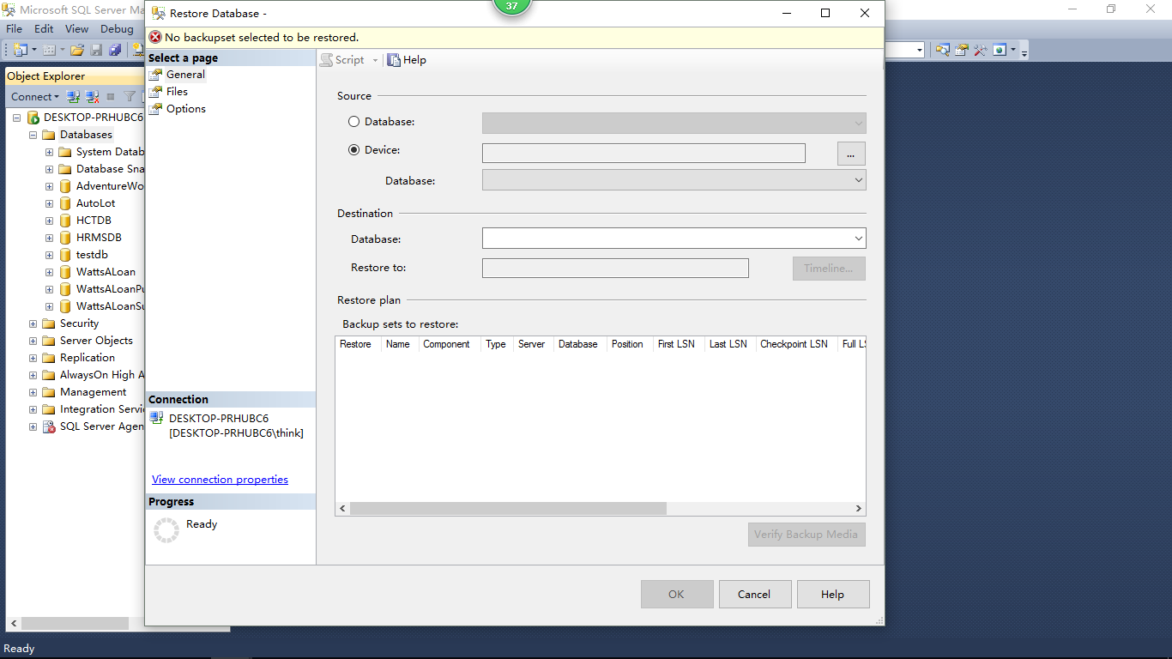

# Select backup device window will appear, click Add button

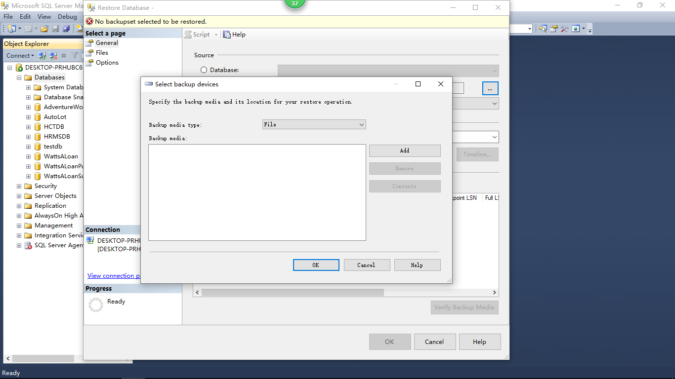

# Find the backup file and click OK. The file will show in Select backup devices window. Click OK to go back Restore Database window.

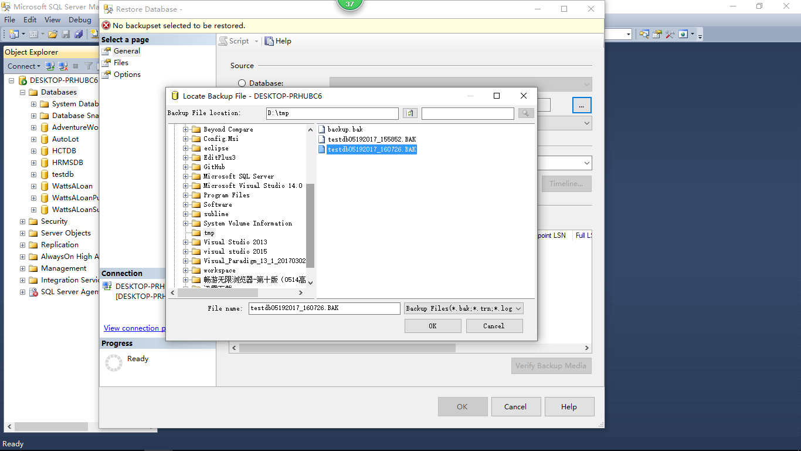

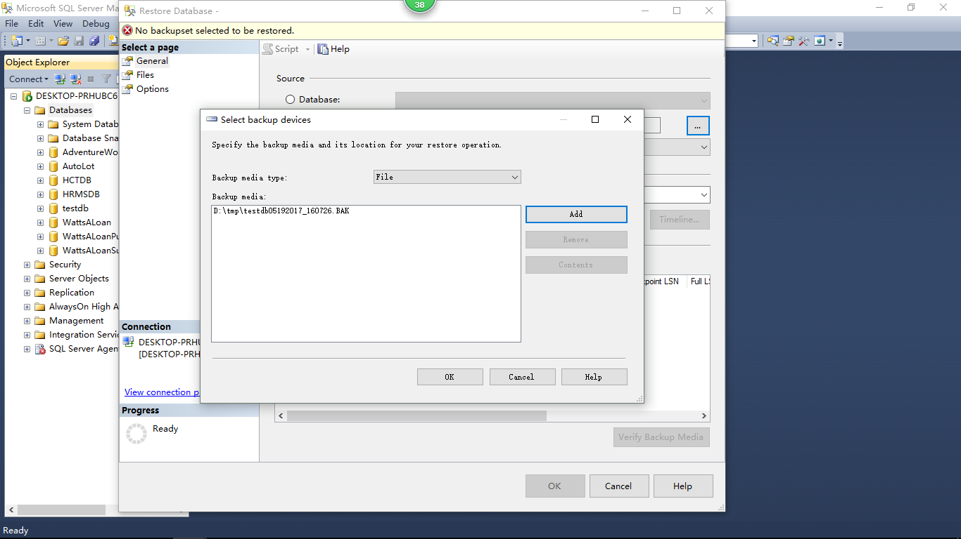

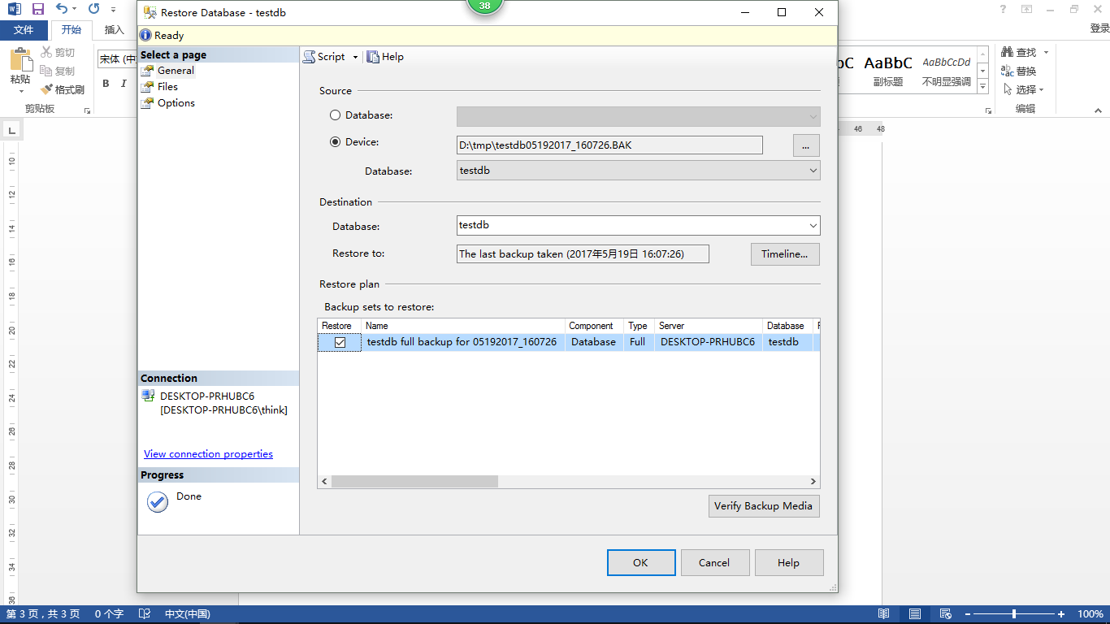

# Click Options and check Overwrite the existing database (WITH REPLACE), then click OK, the database will be restored successfully.

